WEB APPLICATION SECURITY TO SQL INJECTION

**Submitted By:   
Md. Imran Hosen**

Student ID: 2619150011, Batch: 15th

**Supervised by:**   
Renea Chowdhury Shormee, Lecturer & Course Coordinator

Dept. of Computer Science and Engineering/CSIT

Victoria University of Bangladesh



A thesis report submitted to the Department of Computer Science & Information Technology in partial fulfillment of the requirements for the degree of   
B.Sc. in CSIT

Department of Computer Science & Information Technology  
Victoria University of Bangladesh   
03/2022

© 2022. Victoria University of Bangladesh

All rights reserved.

Declaration

I hereby declare that this thesis has been done by me under the supervision of Ms. Renea Chowdhury Shormee, Lecturer & Course Coordinator, Department of CSE/CSIT, Victoria University of Bangladesh. It also declares that neither this thesis nor any part of it has been submitted elsewhere for the award of any degree.

I hereby warrant that the work I have presented does not breach any existing copyright rule.

I further undertake to indemnify the university against any loss or damage arising from breach of the forgoing obligation.

_______________________

**(Md. Imran Hosen)**

**ID –2619150011**

**15th Batch**

Program: B.Sc. in CSIT.

Approval

Certified that the work contained in the project/thesis titled **“Web Application Security to SQL Injection”**, by Md. Imran Hosen, Student ID 2619150011, B.Sc. in CSIT, 15th batch, has been carried out under my supervision and that this work has not been submitted elsewhere for a degree.

|  |  |
| --- | --- |
| __________________________  **Supervisor**  Renea Chowdhury Shormee  Lecturer  Department of CSE/CSIT  Victoria University of Bangladesh | __________________________  **Member**  Md Shahin Khan Shanto  Lecturer and Coordinator  Department of CSE/CSIT  Victoria University of Bangladesh |
|  |  |
| __________________________  **Member**  Umme Khadiza Tithi  Lecturer  Department of CSE/CSIT  Victoria University of Bangladesh | __________________________  **Member ( External)**  Md.Edrich Molla (Jewel)  Assistant Professor and Coordinator  Department of Business Administration  Victoria University of Bangladesh |

# **Dedication**

My Parents.

# **Acknowledgements**

First of all, I am grateful to the Almighty God for giving me the ability to complete the final thesis.

I would like to express my gratitude to my supervisor, Ms. Renea Chowdhury Shormee, for her consistent help with my thesis and research work through her understanding, inspiration, energy, and knowledge sharing. Her direction helped me to find the solutions through research work and arrive at my final theory.

I would like to express my extreme sincere gratitude and appreciation to all of my teachers in the CSE/CSIT department for their kind help, generous advice, and support during my studies.

I am also grateful to all my friends, seniors and juniors, who have directly or indirectly extended a helping hand to this initiative.

Lastly, I would like to thank my family. My parents, first of all, for giving birth to me and supporting me spiritually throughout my life.

Md. Imran Hosen

Abstract

A web application is a software system that provides its users with an interface via a web browser on any operating system. Despite the increasing popularity of web applications, the security threat in web applications has become more diverse, resulting in more severe damage. The big data available on the internet motivates hackers to launch new kind of attacks. The most dangerous attack that target web applications is the Structured Query Language Injection (SQLI). This attack represents a serious threat to the web applications. In this context, intensive research on web application security have been conducted. Several research works have been conducted to mitigate this attack either by preventing it from an early stage or detecting it when it occurs. In this paper, I present an overview of the SQL injection attack and a classification of the newly proposed detection and prevention solutions. I classify the different attack sources, goals, and types. Moreover, I discuss and classify the most important and recent proposed solutions to mitigate this attack especially those based on php (php - Server-Side Scripting languages) some default method to created easy to solve this problem.

Table of Contents

WEB APPLICATION SECURITY TO SQL INJECTION i

Declaration ii

Approval iii

Dedication iv

Acknowledgements v

Abstract vi

Table of Contents vii

List of Tables xii

List of Figures xiii

List of Acronyms xv

Chapter 1 Introduction 1

1.1 SQL Injection 1

1.2 Motivation of the Research 2

1.3 Problem Statement 2

1.4 Project aims and Objectives 2

Chapter 2 Web Application Security Global Analysis 4

2.1 Cybercrime 4

2.2 Global Analysis 6

2.3 Web-application and application-specific attacks 10

Chapter 3 Top 10 Web Application Security Risks 11

3.1 Broken Access Control 11

3.2 Cryptographic Failures 12

3.3 Injection 12

3.4 Insecure Design 12

3.5 Security Misconfiguration 13

3.6 Vulnerable and Outdated Components 13

3.7 Identification and Authentication Failures 13

3.8 Software and Data Integrity Failures 13

3.9 Security Logging and Monitoring Failures 14

3.10 Server-Side Request Forgery 14

Chapter 4 Web Vulnerabilities Detection 15

4.1 Detection of SQL Injection 15

Chapter 5 Vulnerabilities Detection Tools (Web Scanners) 17

5.1 Burp Suite 17

5.2 W3af 20

5.3 Unis can 20

5.3.1 Uniscan Works? 21

5.4 Commix - OS Command Injection and Exploitation Tool 22

5.4.1 Introduction to Command Injection 22

5.4.2 Introduction to Commix 23

5.4.2 Working of Commix 24

5.4.3 Types of Command Injection in Commix 24

Chapter 6 SQLI Attack Sources 26

6.1 Injection through user input 26

6.2 Injection through cookies 26

6.3 Injection through server variables 26

6.4 Stored injection 27

Chapter 7 SQLI Attack Goals 28

7.1 Identifying injectable parameters 28

7.2 Performing database fingerprinting 28

7.3 Determining database schema 29

7.4 Extracting data 29

7.5 Database alteration 29

7.6 Performing denial of service 29

7.7 Bypassing authentication 29

7.8 Executing remote commands 30

7.9 Performing privilege escalation 30

Chapter 8 Type of SQL Injection 31

8.1 The escape character is not filtered correctly 31

8.2 Password Injection 32

8.3 Union Query 33

8.4 Piggy-Backed Queries 34

8.5 Time based SQL 34

8.6 Query manipulation 34

8.7 Inference 35

8.8 Alternate encoding 35

8.9 Stored procedures 35

8.10 Error based SQL 36

Chapter 9 SQL Injection using SqlMap 37

9.1 Where can you use SQLMAP? 38

Chapter 10 Prevention of SQLI 41

10.1 Sanitization 41

10.2 Access on Redirection Setting 41

10.3 Improper Input Validation 41

10.4 Secure Programming 41

10.5 Prepared Statements 42

Chapter 11 Defensive Coding Practices 43

11.1 Trim in php 44

11.2 mysqli_real_escape_string 45

11.3 PHP htmlspecialchars() and htmlentities() Function 46

11.4 preg_replace() in PHP 48

11.5 preg_match in PHP 49

11.6 Sign-in with Validation 51

Chapter 12 Conclusion and Future Works 58

12.1 Findings of the project 58

12.2 Limitations and Future works 58

References 1

Appendix A. 3

List of Tables

Table 1: Percent of attacks and percent of attack types per industry globally 7

Table 2: Most of the attacked top five industry 7

Table 3: Targeted industries experienced a shift in attacks 8

Table 4: Combined application-specific and web-application attacks 9

Table 5: Top five serious vulnerabilities 10

List of Figures

Figure 1: Combined application-specific and web-application attacks 9

Figure 2: Top 10 web application security risks 11

Figure 3: Burp Suite – Web Application Scanner 18

Figure 4: Burp Suite – Testing workflow 20

Figure 5: Uniscaner 21

Figure 6: Uniscan – url scan 21

Figure 7: Uniscan – Blind SQL Injection 22

Figure 8: Commix – automated vulnerability scanner 23

Figure 9:Web Application Sign-in Interface 31

Figure 10: Web Application Login interface 32

Figure 11: SQL Injection with SqlMap 38

Figure 12: SQL Injection with SqlMap 39

Figure 13: SQL Injection with SqlMap 39

Figure 14: SQL Injection with SqlMap 40

Figure 15: Input field or content validation/Sanitization 43

Figure 16: Trim - Remove whitespace including not-breaking spaces, newlines 44

Figure 17: Data sanitization with mysqli_real_escape_string 46

Figure 18: htmlentities() and htmlspecialchars() convert all applicable characters and special characters to HTML entities. 48

Figure 19: preg_replace() – allow only numer and letters 49

Figure 20: preg_match() – allow only valid email format 50

Figure 21: Database to all tables 51

Figure 22: Database users table data 51

Figure 23: User login with Sanitization 52

Figure 24: After Login 53

Figure 25: Post details without parameter validation 54

Figure 26: Post specifics are not displayed. 55

Figure 27: Post id with union query use 56

Figure 28: Post details is show with parameter validation 57

List of Acronyms

|  |  |
| --- | --- |
| IoT | Internet of things |
| PHP | Hypertext Preprocessor. (Earlier called, Personal Home Page) |
| SQL | Structured Query Language |
| SDLC | Software Development Lifecycle |
| SQLI | Structured Query Language Injection |

Chapter 1  
Introduction

1.1 SQL Injection

Web applications have become central in everyone’s lives. We use them to check the email, to make transactions, to socialize, and much more. As their role grew, so did their appealing to hackers, and the number of vulnerabilities has continuously grown year by year.

Reported vulnerabilities have significantly grown over the recent years, with SQL injection (SQLi) being one of the most prominent, especially in web applications, and appearing on Top 10 of OWASP [6]. Furthermore, SQLi is considered to be one of the most devastating web vulnerabilities, as they allow intruders to access private data, and successful attacks cost companies much money for repairs. Also, SQLi vulnerabilities are relatively easy to exploit, making them even more appealing to attackers. For example, they represent two-thirds (65%) of cyberattacks of all web attacks [16].

SQL injection is an attack in which malicious code is inserted into strings that are later passed to an instance of SQL Server for parsing and execution. Any procedure that constructs SQL statements should be reviewed for injection vulnerabilities because SQL Server will execute all syntactically valid queries that it receives. Even parameterized data can be manipulated by a skilled and determined attacker **[3]**.

SQL injection attacks will not stop in a short period of time, and will continue to exist along with the development cycle of computer technology. It is an imminent and costly major threat **[5]**.

Therefore, deploying a web application attack defense strategy including SQL injection attacks is a necessary and primary security task, which is a key step to protect enterprise data as well as user privacy data **[5]**.

SQL injection attacks are achieved by inserting SQL commands into a Web form, domain name, or page request, and finally tricking the server to execute malicious SQL commands, causing great harm to the website and users **[5].**

1.2 Motivation of the Research

5th of September, 2021 I was in my office in the morning. Suddenly, my boss called me. I go to his room. He told me to call your team. I and my team with my boss are going to our big boss room. We are totally unknown. What has happened? We looked at how many people were already present. My big boss told us our organization's most important website has some vulnerabilities. Two people tried SQL Injection on our site. They were successful and they were present. That day, I fixed all our website vulnerabilities with my life experience within 2 hours. This has occurred most effectively in my life for web security.

1.3 Problem Statement

Web application attacks are incessantly increasing in number and in severity. The big data available on the internet motivates hackers to launch new kind of attacks. In this context, intensive research on web application security have been conducted. Though security is very advance these days, even then some intelligent people (Hacker) somehow finds out vulnerability to the security system and exploits it with some techniques. The most dangerous attack that target web applications is the Structured Query Language Injection (SQLI).

1.4 Project aims and Objectives

This project aim to achieve the following objectives:

1) An overview of the SQLI attack will presented. The different types will be describe and discuss attack sources, goals.

2) A classification of the different SQLI attack detection and prevention countermeasures will be presented and discuss.

3) To address this issue, we will present a comprehensive review of the different types of SQL Injection attacks known to date.

4) For each type of attack, we will be provided with descriptions and examples of how attacks of that type could be performed.

5) I will also present and analyze existing detection and prevention techniques against SQL injection attacks.

6) I will discuss its strengths and weaknesses in addressing the entire range of SQL injection attacks.

7) To produce a tool which would detect SQL injection vulnerability automatically and compare that with existing SQL injection detection tools.

8) I discuss and classify the most important and recent proposed solutions to mitigate this attack especially those based on php (php - Server-Side Scripting languages) some default method to created easy to solve this problem.

Chapter 2  
Web Application Security Global Analysis

2.1 Cybercrime

Cybercrime Magazine’s [1] If it were measured as a country, then cybercrime — which is predicted to inflict damages totaling $6 trillion USD globally in 2021 — would be the world’s third-largest economy after the U.S. and China.

Cybersecurity Ventures expects global cybercrime costs to grow by 15 percent per year over the next five years, reaching $10.5 trillion USD annually by 2025, up from $3 trillion USD in 2015. This represents the greatest transfer of economic wealth in history, risks the incentives for innovation and investment, is exponentially larger than the damage inflicted from natural disasters in a year, and will be more profitable than the global trade of all major illegal drugs combined.

The damage cost estimation is based on historical cybercrime figures including recent year-over-year growth, a dramatic increase in hostile nation-state sponsored and organized crime gang hacking activities, and a cyberattack surface which will be an order of magnitude greater in 2025 than it is today.

Cybercrime costs include damage and destruction of data, stolen money, lost productivity, theft of intellectual property, theft of personal and financial data, embezzlement, fraud, post-attack disruption to the normal course of business, forensic investigation, restoration and deletion of hacked data and systems, and reputational harm [1].

While various cybersecurity professionals have suggested that over the next few years passwords will be replaced by other forms of authentication, a new report published by analyst firm, Cybersecurity Ventures, states that the number of passwords in use is actually growing rapidly, and will likely surpass 300 billion by 2020 [2].

The report, entitled The World Will Need to Protect 300 Billion Passwords by 2020, and jointly produced with cybersecurity product vendor, Thycotic, concludes that in just a few years, humans will be using over 100 billion passwords, and connected machines - the number of which continues to grow on an daily basis - will themselves utilize in excess of 200 billion passwords. While estimating such numbers may sound like an academic exercise, if the estimates turn out to be even remotely correct our society faces a substantial challenge: how do we effectively protect so many passwords?

Over the past few years we have seen literally billions of passwords stolen - with some estimates pegging password loss in 2016 alone at over 3 billion (that averages out to almost 100 stolen every second, or over 8 million stolen per day!). With an already less than stellar performance record, how is the world going to be ready to defend many times more passwords in just a few years than it has to now?

According to the report, much of the password growth is from Internet-of-Things devices; such an argument makes sense: while the number of people online is estimated to grow from about 3.4 billion in 2016 to a little over 4 billion by 2020, the number of connected devices is expected to skyrocket from about 15 billion in 2015 to 200 billion in 2020.

On that note, it is important to realize that with an increasing number of connected devices being utilized in medical and industrial facilities, the consequences of IoT password breaches could easily include people dying. And, as we learned last year, many IoT devices lack adequate security - to put it mildly.

How the dust will ultimately settle in terms of IoT security is yet to be determined, but, two things are clear vis-à-vis passwords: 1. Everyone who uses technology is likely going to have to continue to protect his or her passwords for quite some time to come, and 2. cybersecurity professionals are likely going to have a big job on our hands to improve how we protect a rapidly growing password ecosystem and infrastructure.

2.2 Global Analysis

In the 2021 Global Threat Intelligence Report released by NTT Corporation, Globally, organizations faced much of the same types of attacks, though attackers often targeted different technologies.

Organizations in the finance, manufacturing and healthcare industries experienced greater impact than other industries. Malware went through somewhat of a renaissance as multifunction malware continued to make its mark felt. A small number of malware saw wide adoption, but much of those observed appeared to be used in a more targeted manner. Attackers had their preferences depending on the industry being targeted, just like the technology being targeted. New threats made their way into industries and regions. Organizations adapted to embrace the new business models required due to the COVID-19 pandemic and increased their reliance on web based infrastructure.

Finance was the most attacked industry, accounting for 23% of all attacks during 2020. Application-specific attacks continued to dominate finance, accounting for 42% of all attacks. Together, application-specific and web-application attacks make up more than 73% of all attacks on finance [4].

|  |  |
| --- | --- |
| Industry and percent of global attacks | Percent of attack types for industry |
| Finance – 23% | Application-specific – 42%  Web-application – 31%  Reconnaissance – 12% |
| Manufacturing – 22% | Application-specific – 49%  Reconnaissance – 24%  Web-application – 20% |
| Healthcare – 17% | Web-application - 59%  Application-specific – 38%  Known bad source – 1% |
| Business and professional services – 10% | Reconnaissance – 53%  Application-specific – 13%  Brute force – 12% |
| Education – 6% | Web-application – 24%  Application-specific – 22%  Reconnaissance – 21% |

Table : Percent of attacks and percent of attack types per industry globally

The list of the most attacked industries in 2020 includes industries which were all in the top seven most attacked in 2019. However, there was a significant movement in the top five this year. Much was due to actual attack volume changes among the analyzed industries, as both healthcare and business and professional services are new to the top five for 2020 [4].

|  |  |  |  |
| --- | --- | --- | --- |
| Industry | 2018 | 2019 | 2020 |
| Finance | #1 – 17% | #2 – 15% | #1 – 23% |
| Manufacturing | #6 – 7% | #5 – 7% | #2 – 22% |
| Healthcare | #7 – 7% | #6 – 7% | #3 – 17% |
| Business and professional services | #3 – 12% | #7 – 7% | #4 – 10% |
| Education | #4 – 11% | #4 – 10% | #5 – 6 % |

Table : Most of the attacked top five industry

Finance emerged as the most attacked industry, on the strength of a 50% increase in attack volume. Manufacturing jumped from the fifth most targeted in 2019 to the second most targeted in 2020. The volume of attacks against manufacturing targets increased nearly threefold.

Healthcare was the sixth most attacked in 2019 and ended 2020 as the third most attacked, after experiencing an attack volume which more than doubled from the previous year.

Targeted industries experienced a shift in attacks towards the most attacked, with the top three industries accounting for 62% of all attacks. In 2019, the top three industries were targeted in 51% of all attacks. This appears to indicate a trend of attackers concentrating their efforts on more desirable targets, or at least more desirable industries. Nearly every other industry experienced fewer attacks than the previous year [4].

|  |  |  |  |
| --- | --- | --- | --- |
|  | 2018 | 2019 | 2020 |
| Percent of attacks focusing on  the top three industries | 46% | 51% | 62% |

Table : Targeted industries experienced a shift in attacks

Regardless of the specific industries being targeted, rates for application-specific and web-application attacks saw a rise. These attack types continued their combined impact on global industries, accounting for 67% of all attacks, up from 55% in 2019 and 32% in 2018.

They were followed by reconnaissance. No other types of hostile activity had as significant an impact on global attacks than these three attack categories. This is due to the types of vulnerabilities being uncovered, exploits being weaponized in tools, worms, botnets and other malware.

The biggest contributor is likely the increased use of web applications and infrastructures as organizations accelerated cloud adoption. Simply put, hostile threat actors are attacking the technology and functionality newly deployed by organizations. This accelerated during COVID-19 as organizations raced to become digital, increasing their use of client portals and cloud technologies, as well as mobile and web-enabled applications [4].

Figure : Combined application-specific and web-application attacks

|  |  |  |  |
| --- | --- | --- | --- |
|  | 2018 | 2019 | 2020 |
| Share of combined application-specific and web-application attacks | 32% | 55% | 67% |
| Share of combined top three attack types | 48% | 69% | 87% |

Table : Combined application-specific and web-application attacks

Analysis of security tests on applications suggest some industries are simply better at managing application security. Based upon a dynamic vulnerability assessment, we established the average number of vulnerabilities per site across many industries and sub-industries. Utilities showed the highest number of vulnerabilities, with an average of 10 per site. Of the primary industries evaluated for this Report, manufacturing showed the highest average number of vulnerabilities, with nine per site. Finance had the lowest number of average vulnerabilities per site at four. The more vulnerabilities an organization’s site has, the more susceptible to attack they are from hostile actors. These vulnerabilities cover a wide range of issues and potential exposures, such as SQL injections, cross-site scripting vulnerabilities, and directory indexing and data leakage [4].

2.3 Web-application and application-specific attacks

In the 2021 Global Threat Intelligence Report released by NTT Corporation, Web-application (59%) and application-specific (38%) attacks were the top two attack types against healthcare. Combined, web-application and application-specific attacks accounted for 97% of all hostile activity against healthcare. This is the highest concentration of these attack types in any of the industries analysed. The global average for application-specific and web application attacks was 67% of attacks **[4]**.

In most vulnerability classes, the manufacturing industry faces the highest likelihood of exposure. In particular, their likelihood of exposure to A1 – Injection (7%) is over three times the global average (2%). Of these injection exposures, 100% of them are SQL injections. In contrast, their remediation timeframe for both ‘all vulnerabilities’ and ‘serious vulnerabilities’ are among the lowest of the industries analysed (53 days and 50 days, respectively) **[4]**.

|  |  |
| --- | --- |
| Top five serious vulnerabilities | Likelihood of serious exposure |
| Cross-site scripting | 21% |
| Cross-site request forgery | 10% |
| Insufficient authorization | 8% |
| URL redirector abuse | 8% |
| Injection | 7% |

Table : Top five serious vulnerabilities

Chapter 3  
Top 10 Web Application Security Risks

The OWASP Top 10 is a standard awareness document for developers and web application security. It represents a broad consensus about the most critical security risks to web applications [6].

**Top 10 Web Application Security Risks [6]**

There are three new categories, four categories with naming and scoping changes, and some consolidation in the Top 10 for 2021.



Figure : Top 10 web application security risks

3.1 Broken Access Control

Access control, sometimes called authorization, is how a web application grants access to content and functions to some users and not others. These checks are performed after authentication, and govern what ‘authorized’ users are allowed to do. Access control sounds like a simple problem but is insidiously difficult to implement correctly. A web application’s access control model is closely tied to the content and functions that the site provides. In addition, the users may fall into a number of groups or roles with different abilities or privileges.

Developers frequently underestimate the difficulty of implementing a reliable access control mechanism. Many of these schemes were not deliberately designed, but have simply evolved along with the web site. In these cases, access control rules are inserted in various locations all over the code. As the site nears deployment, the ad-hoc collection of rules becomes so unwieldy that it is almost impossible to understand.

Many of these flawed access control schemes are not difficult to discover and exploit. Frequently, all that is required is to craft a request for functions or content that should not be granted. Once a flaw is discovered, the consequences of a flawed access control scheme can be devastating. In addition to viewing unauthorized content, an attacker might be able to change or delete content, perform unauthorized functions, or even take over site administration. [6].

3.2 Cryptographic Failures

Cryptographic Failures shifts up one position to #2, previously known as Sensitive Data Exposure, which was broad symptom rather than a root cause. The renewed focus here is on failures related to cryptography which often leads to sensitive data exposure or system compromise [6].

3.3 Injection

Injection slides down to the third position. 94% of the applications were tested for some form of injection with a max incidence rate of 19%, an average incidence rate of 3%, and 274k occurrences. Notable Common Weakness Enumerations (CWEs) included are CWE-79: Cross-site Scripting, CWE-89: SQL Injection, and CWE-73: External Control of File Name or Path [6].

3.4 Insecure Design

Insecure Design is a new category for 2021, with a focus on risks related to design flaws. If we genuinely want to “move left” as an industry, it calls for more use of threat modeling, secure design patterns and principles, and reference architectures. [6].

3.5 Security Misconfiguration

Security Misconfiguration moves up from #6 in the previous edition; 90% of applications were tested for some form of misconfiguration. With more shifts into highly configurable software, it’s not surprising to see this category move up. The former category for XML External Entities (XXE) is now part of this category [6].

3.6 Vulnerable and Outdated Components

Vulnerable and Outdated Components was previously titled Using Components with Known Vulnerabilities and is #2 in the Top 10 community survey, but also had enough data to make the Top 10 via data analysis. This category moves up from #9 in 2017 and is a known issue that we struggle to test and assess risk. It is the only category not to have any Common Vulnerability and Exposures (CVEs) mapped to the included CWEs, so a default exploit and impact weights of 5.0 are factored into their scores [6].

3.7 Identification and Authentication Failures

Identification and Authentication Failures was previously Broken Authentication and is sliding down from the second position, and now includes CWEs that are more related to identification failures. This category is still an integral part of the Top 10, but the increased availability of standardized frameworks seems to be helping [6].

3.8 Software and Data Integrity Failures

Software and Data Integrity Failures is a new category for 2021, focusing on making assumptions related to software updates, critical data, and CI/CD pipelines without verifying integrity. One of the highest weighted impacts from Common Vulnerability and Exposures/Common Vulnerability Scoring System (CVE/CVSS) data mapped to the 10 CWEs in this category. Insecure Deserialization from 2017 is now a part of this larger category [6].

3.9 Security Logging and Monitoring Failures

Security Logging and Monitoring Failures was previously Insufficient Logging & Monitoring and is added from the industry survey (#3), moving up from #10 previously. This category is expanded to include more types of failures, is challenging to test for, and isn’t well represented in the CVE/CVSS data. However, failures in this category can directly impact visibility, incident alerting, and forensics [6].

3.10 Server-Side Request Forgery

Server-Side Request Forgery is added from the Top 10 community survey (#1). The data shows a relatively low incidence rate with above average testing coverage, along with above-average ratings for Exploit and Impact potential. This category represents the scenario where the security community members are telling us this is important, even though it’s not illustrated in the data at this time [6].

The number third web vulnerability class is called Injection. Injection happens whenever malicious data is sent to a web application, and then an interpreter processes it as part of a command or query (e.g., SQL query). This allows the attacker to trick the interpreter into executing unintended commands or accessing data without proper authorization [6, 7].

Chapter 4  
Web Vulnerabilities Detection

The most critical vulnerabilities are cross-site scripting (XSS), SQL injections (SQLI), and cross-site request forgery (CSRF) that are listed in the top 10 web vulnerabilities by OWASP. The hackers can use the information of these vulnerabilities to compromise the website. Therefore, website requires security countermeasures to secure web application. A variety of techniques is being used around the globe to overcome these vulnerabilities and these techniques assist to identify the website vulnerabilities [5].

The causes of SQL injection vulnerabilities are well-known. One problem is the insufficient validation of input sources. Without validating the input source correctly, an attacker could insert a new SQL keyword through a specially crafted input string to change the developer’s intended SQL query. Due to the fact that the input from potential malicious users can be presumed to be arbitrary values, the program should properly validate this input. Therefore, the application should be able to check the input values that violate the specification. [8].

4.1 Detection of SQL Injection

SQL injection can be detected manually by using a systematic set of tests against every entry point in the application. This typically involves [9]:

* Submitting the single quote mark (‘), double quotation mark (“) or backslash (/) inside input and looking for errors or other anomalies.
* Submitting some SQL-specific syntax that evaluates to the base (original) value of the entry point, and to a different value, and looking for systematic differences in the resulting application responses.
* Submitting Boolean conditions such as OR 1=1 and OR 1=2, and looking for differences in the application's responses.
* Submitting payloads designed to trigger time delays when executed within an SQL query, and looking for differences in the time taken to respond.
* Submitting OAST payloads designed to trigger an out-of-band network interaction when executed within an SQL query, and monitoring for any resulting interactions.

SQL injection attacks have different features from normal URLs. Not only do they include sql-related keywords, but the form of the parameters is more complex than normal parameters, this is due to the attacker's careful construction of parameters, so that parameters can be successfully executed to achieve the malicious purpose after arriving at the server [10].

Chapter 5  
Vulnerabilities Detection Tools (Web Scanners)

The most common attacks on Web servers are SQL injection attacks (when the web server is connected to a SQL database) [10].

5.1 Burp Suite

The majority of SQL injection vulnerabilities can be found quickly and reliably using **“Burp Suite”.**  Burp Suite is a web vulnerability scanner used in a great many organizations. Although there is a free version available, it is limited in functionality, with no automation capabilities. Those wishing for the complete package for enterprise-wide scalability and automation should be prepared to pay well. Security professionals needing only a good automated vulnerability scanner for testing of code can make do with the Professional version, which is cheaper **[9].**

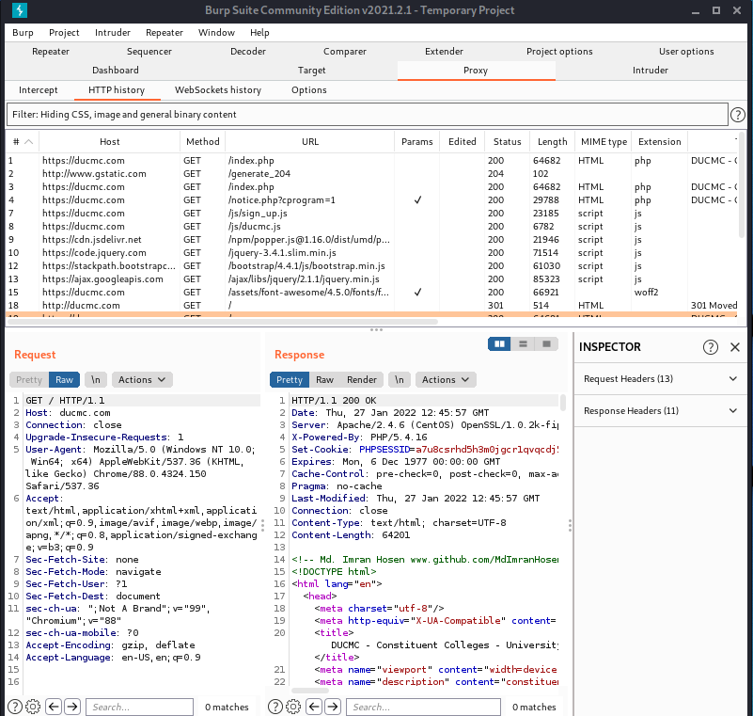

Figure : Burp Suite – Web Application Scanner

The Burp tools you will use for particular tasks are as follows:

* **Scanner -** This is used to automatically scan websites for content and security vulnerabilities.
* **Intruder -** This allows you to perform customized automated attacks, to carry out all kinds of testing tasks.
* **Repeater -** This is used to manually modify and reissue individual HTTP requests over and over.
* **Collaborator client -** This is used to generate Burp Collaborator payloads and monitor for resulting out-of-band interactions.
* **Clickbandit -** This is used to generate clickjacking exploits against vulnerable applications.
* **Sequencer -** This is used to analyze the quality of randomness in an application's session tokens.
* **Decoder -** This lets you transform bits of application data using common encoding and decoding schemes.
* **Comparer -** This is used to perform a visual comparison of bits of application data to find interesting differences.

**Testing workflow:**

Burp lets you combine manual and automated techniques effectively, gives you complete control over all of the actions that Burp performs, and provides detailed information and analysis about the applications you are testing.

Some users may not wish to use Burp in this way, and only want to perform a quick and easy vulnerability scan of their application. If this is what you need, please refer to Scanning web sites.

The diagram below is a high-level overview of the key parts of Burp's penetration testing workflow:

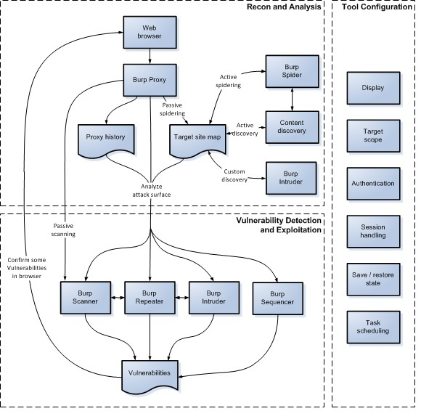

Figure : Burp Suite – Testing workflow

5.2 W3af

W3af is one of the most powerful Web Application scanners. It is written in Python. Its modular architecture allows users to easily import and modify its different modules. In particular, SQLi module is intended to detect SQL injections from authentication forms. More precisely, it sends the string d’z”0 (or d% 2Cz% 220 in ASCII code) to every injection point, and searches for SQL errors in the response body. **[11, 12].**

5.3 Unis can

**Uniscan** is a simple Remote File Include, Local File Include and Remote Command Execution vulnerability scanner. It’s a very simple yet quite powerful tool to scan website for vulnerabilities in Kali Linux (or any Linux as a matter of fact). It does the job fast and without hassle. You don’t need too much experience to run it, but you might need a good internet connection and a very long time **[12].**

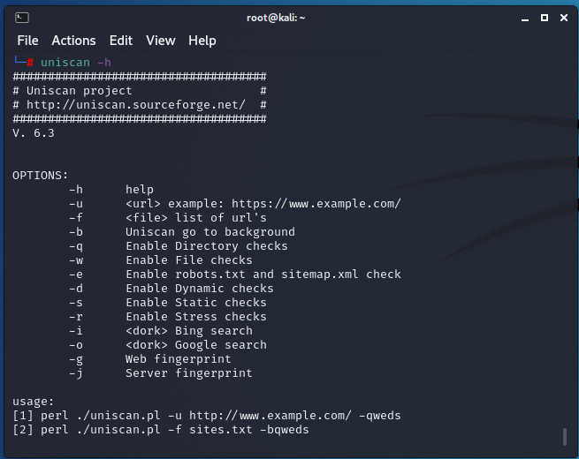

Figure : Uniscaner

5.3.1 Uniscan Works?

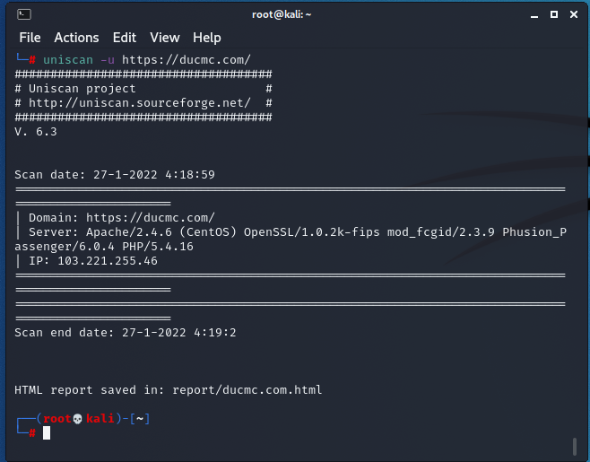

Figure : Uniscan – url scan

The GUI Interface if Uniscan tool can be activated through the uniscan-gui command on the terminal. The interface is quite friendly with the new hackers. All the options can be used with a single click. Firstly, we need to specify the target domain URL for which the process will be done. Then we need to select the options which will be performed on the domain like directory check, file check, robots.txt file check, web fingerprinting, server fingerprinting, dynamic test option, static test option, and stress test. All the activities are saved in the log files which can be used as the result file for our scans on the target domain.

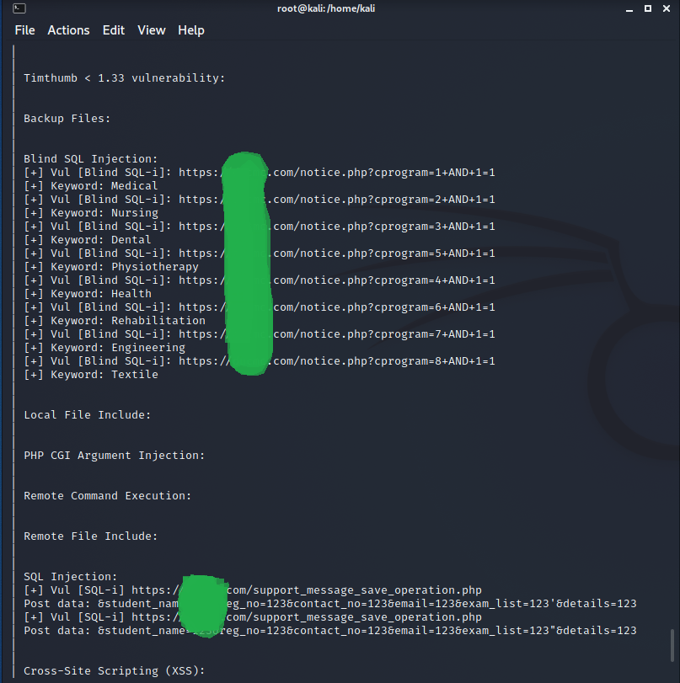

Figure : Uniscan – Blind SQL Injection

5.4 Commix - OS Command Injection and Exploitation Tool

Commix is an open source penetration testing tool, written by Anastasios Stasinopoulos, that automates the detection and exploitation of command injection vulnerabilities. **[19].**

5.4.1 Introduction to Command Injection

Command injection is also known as shell injection or OS injection. Command injection is one of the top 10 OWASP vulnerability. it’s an attack in which arbitrary commands of a host OS are executed through a vulnerable application. Such an attack is possible when a web application sends unsafe user data to the system shell. This user data can be in any form such as forms, cookies, HTTP headers, etc. Mostly the vulnerability command injection rises due to insufficient input validation. In this attack, the default functionality of the application is extended by an attacker who then executed the system commands with injecting code which makes it different from code injection.

The process of command injection was accidentally discovered in 1997 by a programmer in Norway. This accident led to the deletion of web pages of a site. SQL command injection is the most popular form of command injection. Through this attack, an attacker adds SQL code to the input box in order to gain access. Web applications are compulsory for such attacks as we communicate with the underlying OS via such web applications.

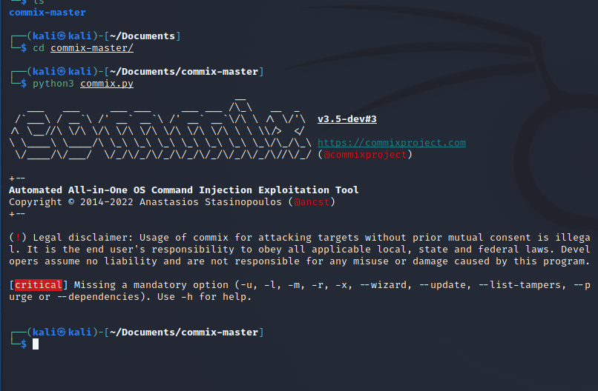

Figure : Commix – automated vulnerability scanner

5.4.2 Introduction to Commix

Commix tool is automated for exploiting the vulnerability of command injection in web applications. This tool is written in python which means it is compatible with Linux, windows and mac. It comes pre-installed in Kali Linux and Parrot OS. This tool makes it very easy to find vulnerabilities related to command injection and then further exploit them. The user-friendliness of commix makes it very convenient for everyone, such as web developers, pen testers or security researchers, to use it.

It provides a user with a lot of options such as including the ability to specify parameters that you need to connect to host, enumeration of a victim, accessing files and their modification along with an offline mode. Hence, it’s a pretty useful asset in order to exploit command injection vulnerability.

5.4.2 Working of Commix

Commix has various command options which you can use to find and connect with the target application. Few of the options target URL is via data strings, HTTP headers, cookies and authentication parameters. There are various enumerations options present too. Commix supports two command injection techniques i.e. result-based command injection technique and blind command injection technique. Result based command injection is the once where commands are reflected back to the attacker in the web application. Whereas blind command injection technique is persuading when the response is not reflected on a web application.

5.4.3 Types of Command Injection in Commix

**Result based command injection**

This type of injection attack will let you deduce the result of the injected command through the result of a web application. It is further divided into two categories:

* Classic result based injection: This is the most commonly used type of command injection and is the simplest of all. In this, several common operators are used which either links genuine commands with the injected ones or exclude the initial commands altogether and goes ahead to execute the injected ones only. this further divides into 3 categories i.e. Shellshock, ICMP exfiltration, DNS exfiltration.
* Eval-Based technique: This technique is used where the targeted web application is vulnerable to eval() function. This eval function is used to execute the peculiar code that is defined in the said function during run time.

**Blind Command Injection**

The way that the data is retrieved after the execution of injected shell command is the main difference between the working of both the types. In the case where web application does not give any result back to the attacker; blind command injection is used. There are further two types of blind command injection:

* Time-based Technique: Using this technique will delay the time of the execution of a command that is injected. By checking how much time the application took to revert will able the attacker to determine whether the command is executed successfully or not.
* File-based Technique: If you are not able to determine the result of the web application through its reaction, then this technique comes in handy as it will allow you to write the set of commands that are to be injected in the file accessible to the attacker. Working of this technique is similar to that of result based technique [18].

Chapter 6   
SQLI Attack Sources

6.1 Injection through user input

Web applications, generally, use forms to collect data from users (such as registration, login, etc.) or to permit users to specify the data to be retrieved (such as search, adapted view, etc.). These forms containing ”text field” could be exploited by attackers to inject malicious code, which results in gaining an indented data (retrieve secret data, etc.) or making an indented actions (manipulate database, etc.). Common fields are Login Name, Password, Address, Phone Number, Credit Card Number, and Search.

6.2 Injection through cookies

Recent web applications use cookies to store users preferences. Cookies are files stored on the client machine, which contain state information generated by the web applications. An attacker could embed malicious code into the cookies contents stored in his computer, and therefore, putting web application using the cookies contents to build SQL queries vulnerable to attacks.

6.3 Injection through server variables

Server variables are a set of parameters that contain network headers, HTTP metadata, and environmental variables. Generally, web applications use these server variables for auditing

usage statistics and identifying browsing trends. If these variables are stored to a database without validation, attackers can exploit this vulnerability by placing an SQLIA directly into the server variables.

6.4 Stored injection

In stored injection (called also second-order injection), attackers embed malicious inputs into a database to indirectly launch an SQLIA each time that input is used. The following code, shows an example of second-order SQL injection. In this example, the attacker as a normal user of the website, firstly registers to the application with a seeded username like ”admin’- -”. Then, the attacker will try to change his password. The SQL query to change a user password has generally the following form:

|  |
| --- |
| queryString=”UPDATE users SET password=’” + newPassword +”’ WHERE userName=’” + userName + ”’ AND password=’” +oldPassword + ”’” |

Assume that newPassword and oldPassword are “newpwd” and “oldpwd”, which are chosen by the attacker, the query that will be sent to the database is the following:

|  |
| --- |
| **Error # -2147217887 (0x80040E21)**  **ODBC driver does not support the requested properties.**  SELECT card.cardid, card.number, card.password,users.name,users.email,account.amount FROM card JOIN users ON card.cuserid = users.userid JOIN account ON account.userid = users.userid WHERE users.userid = 1 AND account.status = 1 |

|  |
| --- |
| UPDATE users SET password=”newpwd” WHERE userName= ”admin” - - ” AND password=”oldpwd” |

Because ”- -” is the SQL comment operator, everything after it is ignored, the result of this query is that the database changes the password of the administrator (“admin”) to an attacker-specified value [14].

Chapter 7  
SQLI Attack Goals

Hackers can have different intend and goals for launching the SQLI attack. The main SQLI attack goals are:

7.1 Identifying injectable parameters

As a first step, hackers try to identify which parameters could be used to inject malicious code. These parameters could be present in one of the sources described in Subsection II-A. More precisely, these parameter could be a ”username” field in a form, a ”card number” in a cookie, etc. An attacker can modify the logic of the statement by injecting SQL code, so that when executed it performs another action. For example, injecting a single quote that is used in SQL to delimit the start or end of a string value could disrupt the pairing of string delimiters and generate an application error, indicating a potential vulnerability to SQL injection.

7.2 Performing database fingerprinting

To construct a query format supported by the target database engine, the attacker needs to know the database finger-print. Database finger-print is the information that identifies a precise type and edition of a database system. Each database system uses a different proprietary SQL language syntax. For example, Microsoft SQL server uses T-SQL while Oracle SQL server uses PL/SQL. As a consequence, the attacker must first find out the type and version of the database used in a web application, and then craft malicious SQL input for that database. Moreover, default vulnerability associated with that version of database can be exploited by attackers.

7.3 Determining database schema

To successfully extract data from a database, the attacker needs to know the database schema information, such as table names, column number and names, and column data types. The database schema is used by hackers to create an accurate consequent attack with the purpose of extract or modify data from database. Figure 1 presents an error message returned by the database system that shows different information related to the database schema (such as number and name of columns) and system (such as ODBC). These pieces of information can be exploited by hacker to construct a successful SQLI attack.

7.4 Extracting data

These types of attacks employ techniques in order to extract data values from the database. This attack presents critical risk to web application as extracted information could be sensitive and highly top secret to the web application (example getting customer bank information). Attacks with this intent are the most common type of SQLIA.

7.5 Database alteration

The goal of these attacks is to alter or change information in a database. For illustration, a hacker can pay much less for an online product by modifying its price, which is generally stored in a database. Another possible attack, consists in adding a malicious link in an online discussion database to commence succeeding Cross-Site-Scripting attacks.

7.6 Performing denial of service

This attack intend is to deny service to other users and can have different form, such as shutdown the database of a web application, locking or dropping database tables, etc.

7.7 Bypassing authentication

The aim of this attack is to bypass the authentication mechanisms of the web application. If the intruder succeed to launch such attack it could take the rights and privileges of another user, generally with high rights and privileges.

7.8 Executing remote commands

Remote commands are executable code resident on the compromised database server. These commands can be stored procedures or functions available to database users. In this type of attacks, hackers attempt to execute arbitrary commands on the database, which can lead to denial of service by executing the shutdown command or database disruption.

7.9 Performing privilege escalation

These attacks try to escalate the privileges of the attacker taking advantage of some implementation errors or logical flaws in the database. As opposed to bypassing authentication attacks, these attacks focus on exploiting the database user privileges. This attack can have a critical consequence especially when the attacker gains the root privilege [14].

Chapter 8  
Type of SQL Injection

8.1 The escape character is not filtered correctly

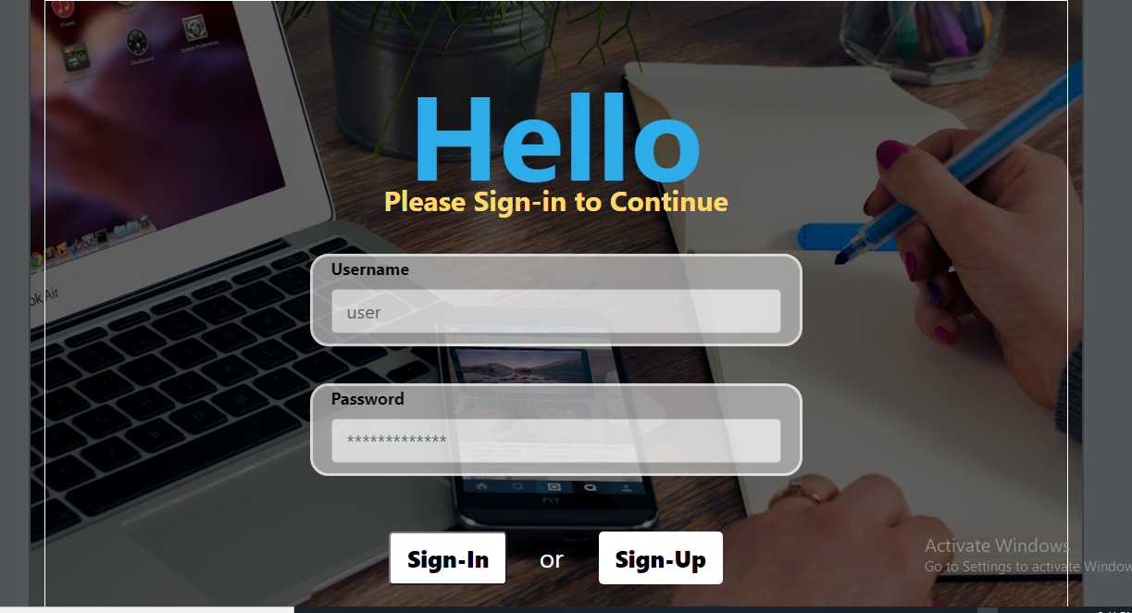

Figure :Web Application Sign-in Interface

This form of injection attack occurs when the user's input is not filtered for escape characters, and it is passed to an SQL statement. This will result in the end user of the application manipulating the statements on the database. For example, the following line of code demonstrates this vulnerability: Statement: = "SELECT * FROM users WHERE name ='" + userName + ";" The purpose of this code is to extract a particular user from its user table, but if the user name is forged by a malicious user in a specific way, the operation performed by this statement may not be just what the author of the code expects. For example, set the username variable to: 'a' or 't'='t, when the original statement changes: SELECT * FROM users WHERE name ='a' OR 't'='t'; If this code is used in an authentication process, this example can force the selection of a legitimate username, because assigning 't'='t is always correct. On some SQL servers, such as in SQL Server, any SQL command can be injected in this way, including executing multiple statements. The value of username in the following statement will result in the deletion of the "users" table and the selection of all data from the "data" table (which in fact reveals the information of each user). a'; DROP TABLE users; SELECT * FROM data WHERE name LIKE'% This makes the final SQL statement look like the following: SELECT * FROM users WHERE name ='a'; DROP TABLE users; SELECT * FROM DATA WHERE name LIKE'%'; Other SQL executions do not take executing multiple commands in the same query as a security measure. This prevents an attacker from injecting a completely independent query, but doesn’t prevent an attacker from modifying the query [20].

8.2 Password Injection

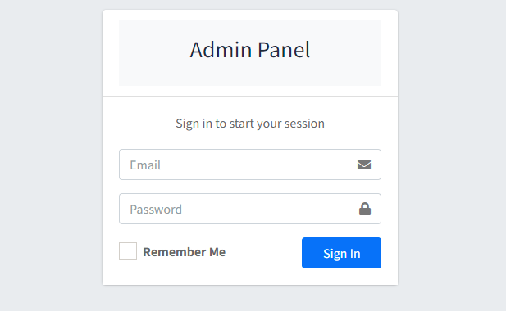

Figure : Web Application Login interface

Web Application Login functionality in a website asks username, user-id or Email and password to login for authentication. The request sent from the browser will contain two parameters possibly username = administrator and strong-password. Then parameters with request to server a SQL query is generated.

Like: user = get-request-user;

pass = get-request-pass;

SELECT * FROM user WHERE username = “user” AND password = “pass”;

When the query is sent to database, it is compared to the value from the data present in database and on successful result comparison query will be true and user will be logged in. When a SQL command or syntax can also be the part of parameter`s value sent to database. An unauthenticated user, with no knowledge of the password, can send a crafted input which can looks like this:

req-user = “1 OR 1=1”;

req-pass = “1 OR 1=1”;

SELECT * FROM user WHERE user = “1 OR 1 = 1” AND password = “1 OR 1 = 1”;

This statement will always result in TRUE because of OR Boolean operator and 1=1 is universal truth. And in this case unauthenticated user will be logged in but without having any password by tricking the SQL query and database. This , in general, is called SQL Injection **[13].**

8.3 Union Query

In union query attack, the attacker uses the **UNION** operator to join a malicious query to the original query. The result of the malicious query will be joined to the result of the original query, allowing the attacker to obtain the values of columns of other tables. The following query is an example of a union query SQL injection attack:

SELECT accounts FROM users WHERE login=” UNION SELECT cardNo from CreditCards where acctNo=10032 - - AND pass=” AND pin=

Although, the original first query returns the null set, whereas the second query returns data from the ”CreditCards” table **[14].**

8.4 Piggy-Backed Queries

In piggy-backed query attack, the attacker intends to inject additional queries to extract data, modify or add data. Attackers inject additional queries to the original query, and as a result the DBMS receives multiple SQL queries. The following query is an example of a piggy-backed query SQL injection attack **[14]:**

SELECT ∗ FROM userDetails WHERE userid = ’12’ and password = ’cle’; drop table userDetails;

8.5 Time based SQL

This attack depends on database pausing for a given amount of time, then returning the results indicating a successful SQL query execution. For example: If the first character of Administrator account`s password is ‘I’ then wait for 10 seconds. This can be done using SLEEP query. If the requested query is true the database will respond after 10 seconds or whatever is specified in query. [13].

8.6 Query manipulation

Query manipulation is a vulnerability related to structures that store data like databases and where malicious code manipulates queries and changing them. With the help of these web vulnerabilities, a hacker easily manipulates the parameter of user input. As a result, the attacker becomes able to change the query‘s syntax. When the validation of these parameters is not proper, the maliciously infected parameters enter the reliable website due to which unsafe and unreliable information enters the web applications and damage its security [5].

8.7 Inference

In this type of attack, database is not providing any error message by which we can modify our query or get any sensitive information. Therefore, we use to ask questions to database in terms of true false regarding the data values inside the table of database [17].

8.8 Alternate encoding

In alternate encoding, the attacker tries to conceal the injected text in order to avoid detection by defensive coding practices and automated prevention techniques. More precisely, alternate encodings are enabling techniques that allows attackers to escape detection countermeasures. These evasion techniques are widely used by intruder because they know that most IDS scan the query for certain known ”bad characters”, such as single quotes and comment operators. By changing the character encoding a malicious code can evade detection mechanism. The following query shows an example of alternate encoding SQLIA:

|  |
| --- |
| SELECT accounts FROM users WHERE login=”legalUser”; exec(char(0x73687574646f776e)) - - AND pass=”” AND pin= |

The char() function, cited in this example, takes an integer or hexadecimal encoding of a character as input and returns the character spelling. The stream of numbers in the second part of the injection is the ASCII hexadecimal encoding of the string ”SHUTDOWN”. This result in database shutdown and might lead to denial of service attack.

8.9 Stored procedures

In stored procedures, the attacker aims to run stored procedures already saved in the database. Indeed, most existing databases are extended with a standard set of implemented functions called stored procedures that allow even the interaction with the operating system. These stored procedures are generally invoked by developers in their codes to avoid re-writing standard functions. Therefore, an attacker can exploit this property and once determines the web application backend database, SQLIAs can be crafted to execute stored procedures existing in the determined database, including even procedures that interact with the operating system [17].

8.10 Error based SQL

In this Error based SQL attack we use to send a unexpected input to generate some errors. And based on those error which have some info in it, we will recreate our payload for getting towards successful payload [13].

Chapter 9  
SQL Injection using SqlMap

sqlmap is an open source penetration testing tool that automates the process of detecting and exploiting SQL injection flaws and taking over of database servers. It comes with a powerful detection engine, many niche features for the ultimate penetration tester, and a broad range of switches including database fingerprinting, over data fetching from the database, accessing the underlying file system, and executing commands on the operating system via out-of-band connections.

It works for all modern databases including mysql, postgresql, oracle, microsoft sql server, etc.

SQL Injection is an injection flaw where user input could alter the SQL query being constructed and executed by the application.

SQLMAP automates common SQL injection techniques like:

* Error Based
* Time Delay
* Stacked Queries
* Boolean Based
* Union Based

9.1 Where can you use SQLMAP?

1. First open kali Linux => open Terminal => Type “sqlmap –h”
2. Find out vulnerable site url like: http://domain.com?ac=1
3. Type: sqlmap –u http://domain.com?ac=1 --dbs

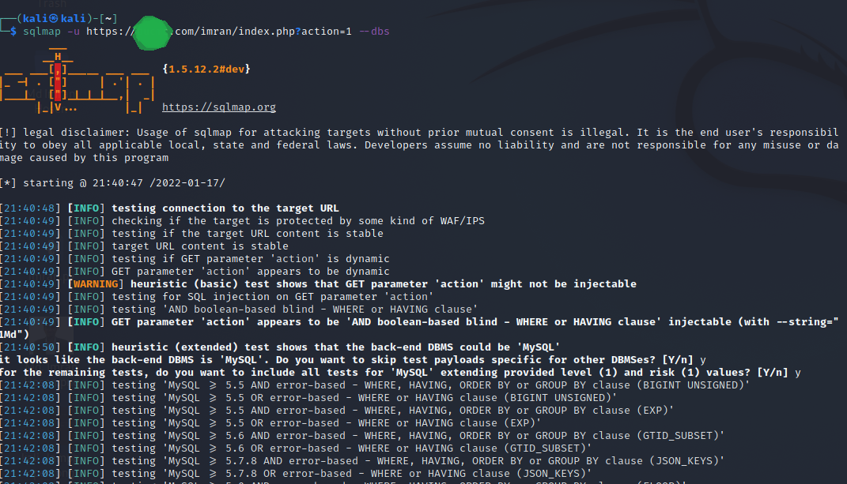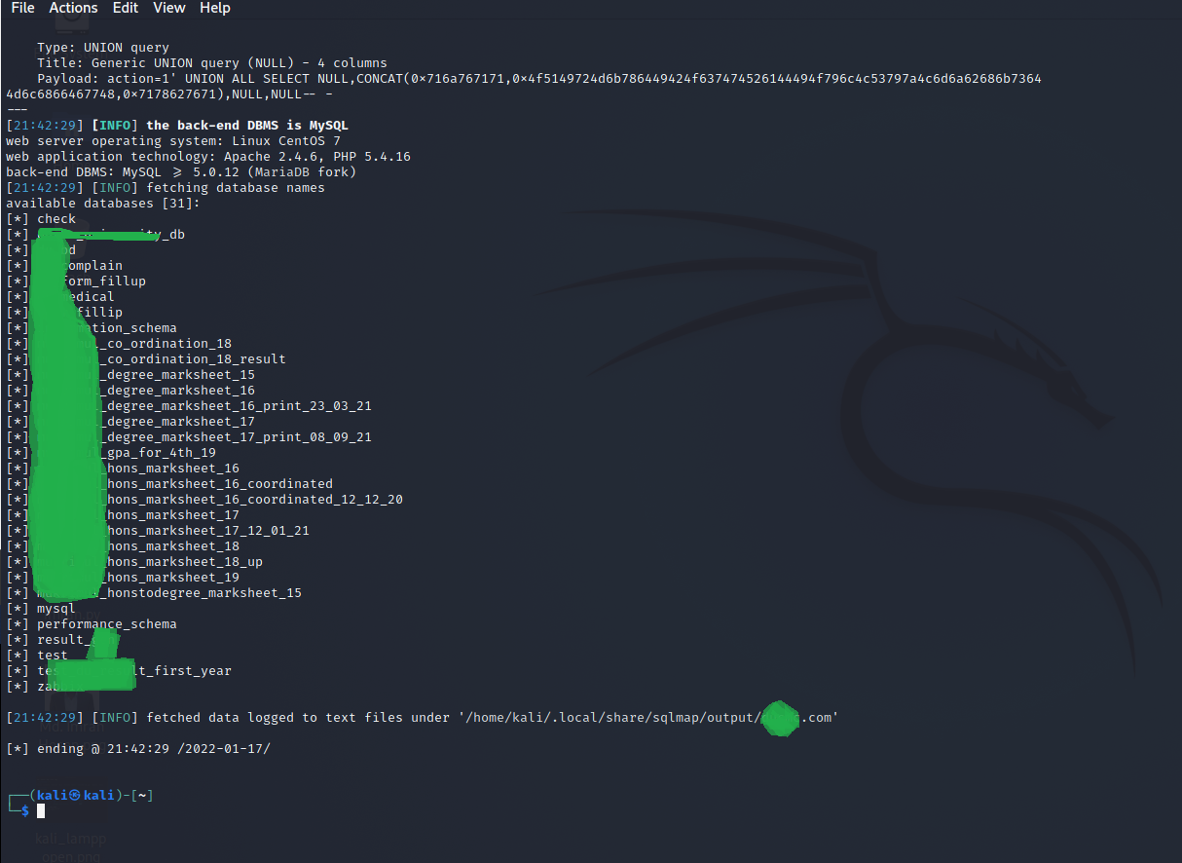

Figure : SQL Injection with SqlMap

1. If you are get all tables type: sqlmap –u http://domain.com?ac=1 –D dbName --tables

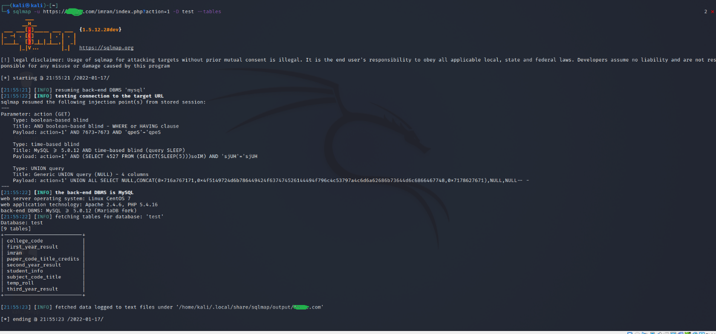

Figure : SQL Injection with SqlMap

1. Get table attributes type: sqlmap –u http://domain.com?ac=1 –D dbName –T tableName --columns

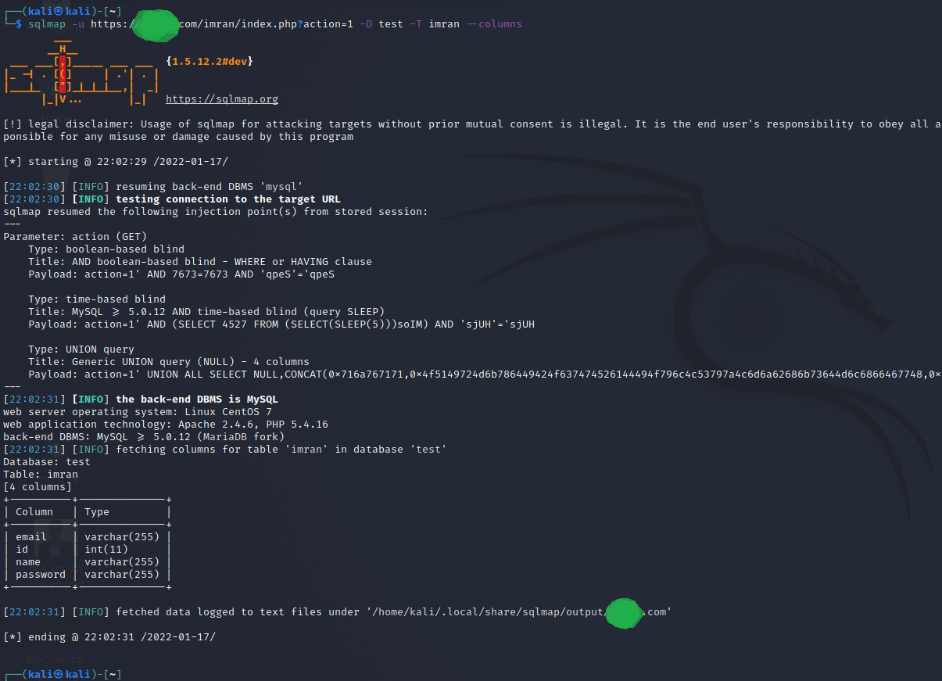

Figure : SQL Injection with SqlMap

1. Get attributes data type: sqlmap –u http:domain.com?ac=1 –D dbName –T tableName –C attributeName --dump

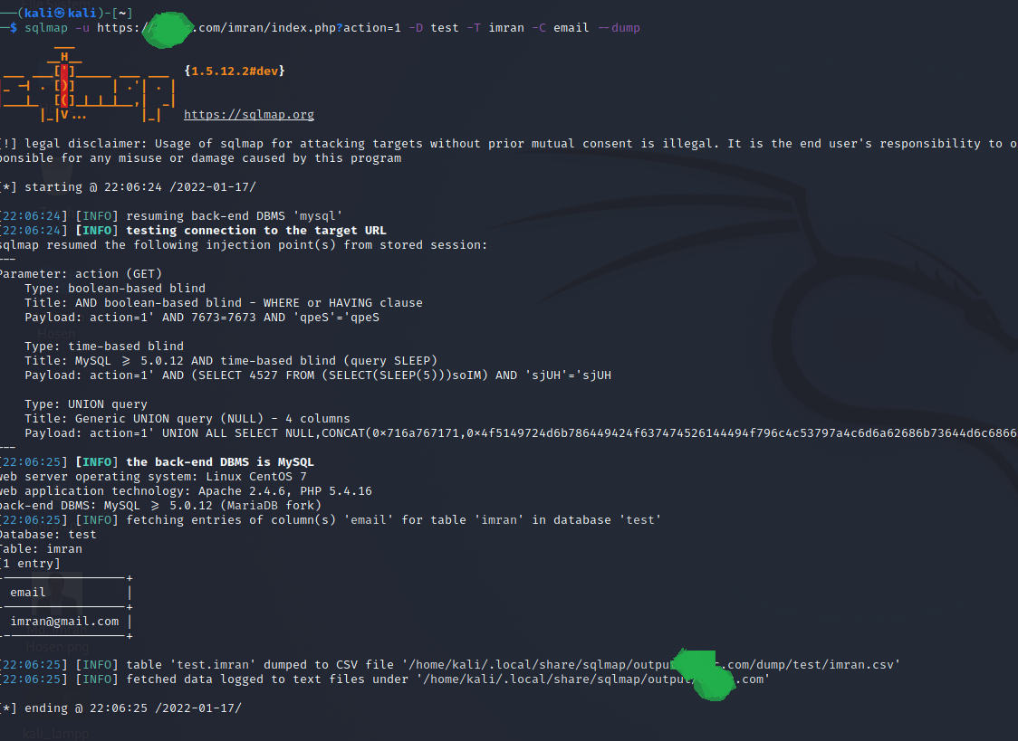

Figure : SQL Injection with SqlMap

Chapter 10  
Prevention of SQLI

10.1 Sanitization

When an attacker injects malicious SQL statements into the input host variables, they might be able to access the data of the database or extract private information. Sanitization is a type of input validation method that is performed to remove malicious elements from the input provided by the user. In addition, sanitization is performed before external input parameters are used in SQL statements and specify a regular expression or a builtin validation function in input sources [8].

10.2 Access on Redirection Setting

It is one of the best practices of the designer/ developer of web application to separate administrative section pages from the general user panel for avoiding unauthorized access.

10.3 Improper Input Validation

The web application is must validate or sanitize user input properly before its utilization in the web servers. Usually, web developers exercise sanitizing practices for the transformation of inputs by the user into trusted data through filtration [5].

10.4 Secure Programming

Secure programming allows programmers to follow secure practices when they are developing the web application. Secure Programming protects coding practices by coding properly, checks the input data; encode correctly the user input, its type further by setting the query‘s parameter, also by bringing stored procedures to work [5].

10.5 Prepared Statements

SQL injection can be generally prevented by using Prepared Statements . When we use a prepared statement, we are basically using a template for the code and analyzing the code and user input separately. It does not mix the user entered query and the code. For prepared statements, we basically send the sql query with a placeholder for the user input and then send the actual user input as a separate command.

Consider the following php code segment.

$db = new PDO('connection details');

$stmt = db->prepare("Select name from users where id = :id");

$stmt->execute(array(':id', $data));

In this code, the user input is not combined with the prepared statement. They are compiled separately. So even if malicious code is entered as user input, the program will simply treat the malicious part of the code as a string and not a command.

Chapter 11  
Defensive Coding Practices

Secure programming allows programmers to follow secure practices when they are developing the web application. Secure Programming protects coding practices by coding properly, checks the input data; encode correctly the user input, its type further by setting the query‘s parameter, also by bringing stored procedures to work.

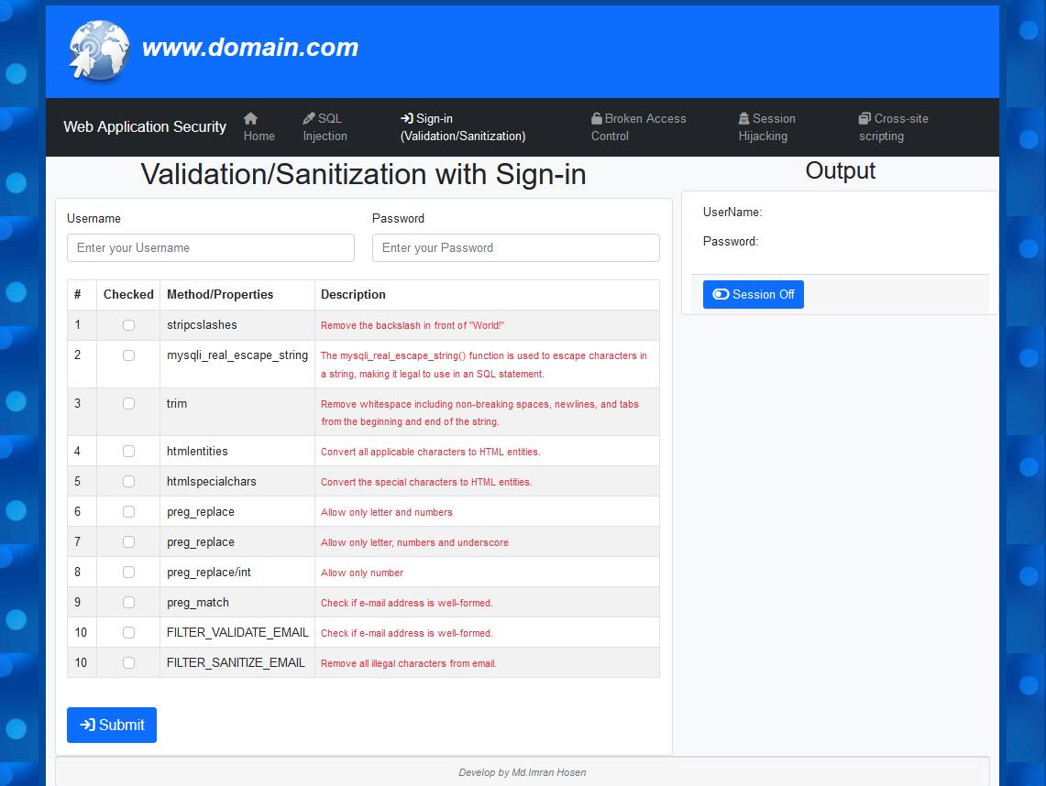

Figure : Input field or content validation/Sanitization

11.1 Trim in php

You can use the PHP trim() function to remove whitespace including non-breaking spaces, newlines, and tabs from the beginning and end of the string. It will not remove whitespace occurs in the middle of the string.

Example:

<?php

$ver_trim = “ Test Keyword ”;

$ver_trim = trim($ver_trim);

Echo $ver_trim;

Output is: Test Keyword // without whitespace

?>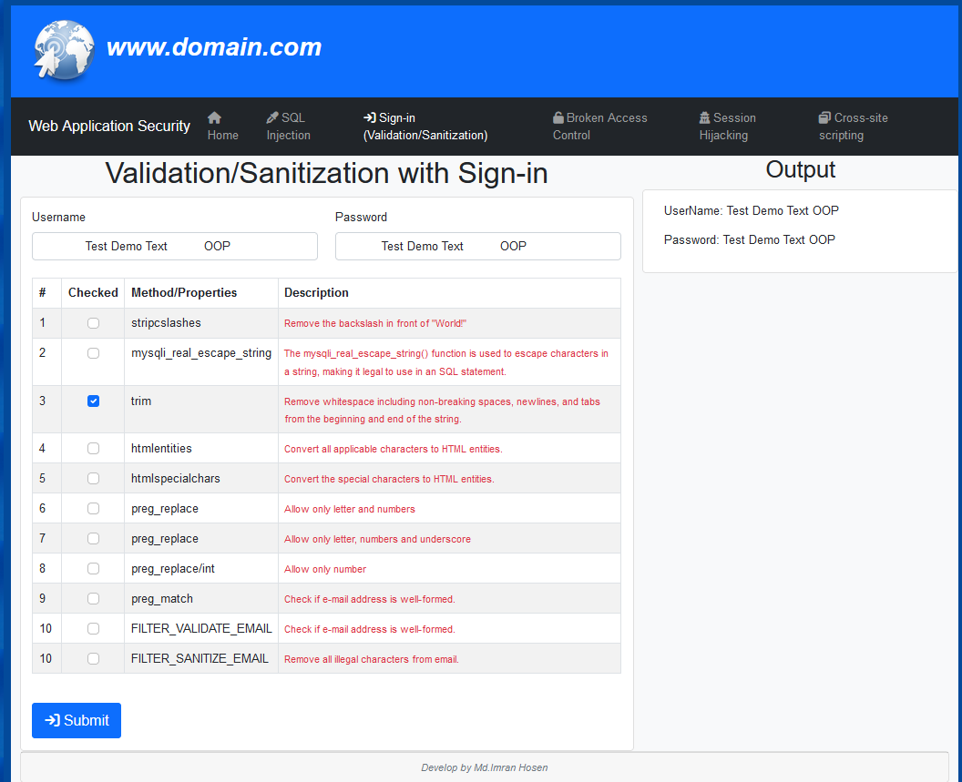

Figure : Trim - Remove whitespace including not-breaking spaces, newlines

11.2 mysqli_real_escape_string

mysqli_real_escape_string() is related to any security issues. Which is but a grave delusion. This is a **string formatting function** that protects you from SQL injections only as a side effect. But such a protection is neither the goal nor the purpose of the function. And therefore it should never be used for the purpose.

In the inherent separability of the code you posed. The protection consists of **three** parts:

* setting the correct encoding
* escaping special characters
* wrapping the escaped value in quotes

It is not only the fact that some of these obligatory measures could be forgotten but again, the statement of question stresses only on a single part - escaping. It is only escaping which is always accented on, while two other measures get hardly mentioned at all. Just look at your question - you meant the code but asked about a function. So any literal answer to the question you asked will make a fatally wrong impression that mysqli_real_escape_string() is all right.

In short, the statement of question helps to promote the most dangerous of PHP related delusions: that this function protects from SQL injection [21].

**Example:** <?php

$my_escape_string = “Test Keyword <script>alert(‘hack’);</script>”;

$my_escape_string = mysqli_real_escape_string($db_connect, $my_escape_string);

// $db_connect - Database connection

Echo $my_escape_string;

Output is: Test Keyword <script>alert(\’hack\’);<script>

?>

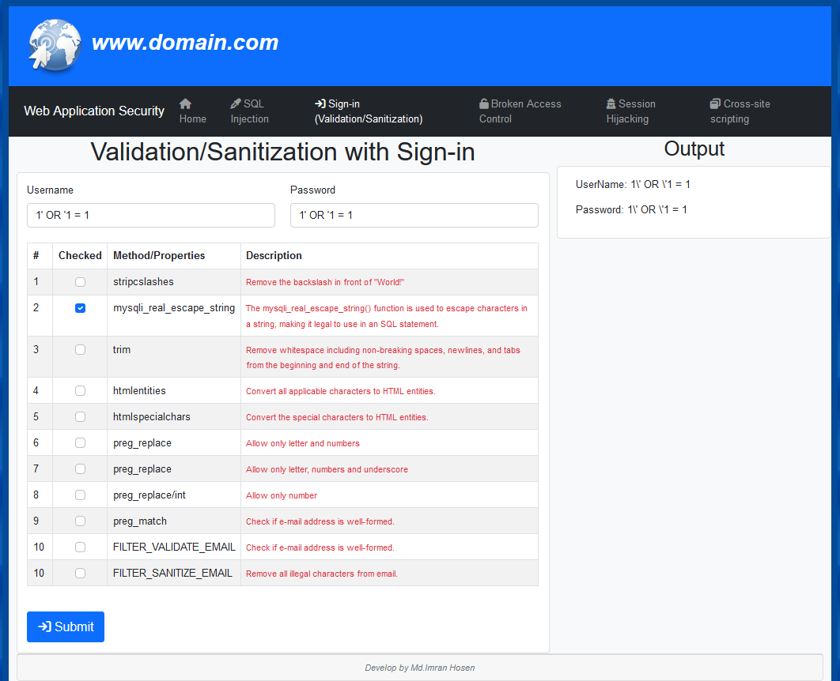

Figure : Data sanitization with mysqli_real_escape_string

11.3 PHP htmlspecialchars() and htmlentities() Function

The htmlspecialchars() function converts special characters into HTML entities. It is the in-built function of PHP, which converts all pre-defined characters to the HTML entities. The pre-defined characters are:

* **&** (ampersand) converted as **&amp;**
* **"** (double quote) converted as **&quot;**
* **'** (single quote) converted as **&#039;**
* **<** (less than) converted as **&lt;**
* **>** (greater than) converted as **&gt;**

Difference between htmlentities() and htmlspecialchars() function: The only difference between these function is that htmlspecialchars() function convert the special characters to HTML entities whereas htmlentities() function convert all applicable characters to HTML entities.

Example:

<?php

$var_html_en_espc = “& Test Demo ! & > ”;

$var_html_en_espc = htmlentities($var_html_en_espc);

$var_html_en_espc = htmlspecialchars($var_html_en_espc);

Echo $var_html_en_espc;

Output: &amp; Test Demo ! &amp; &gt;

?>

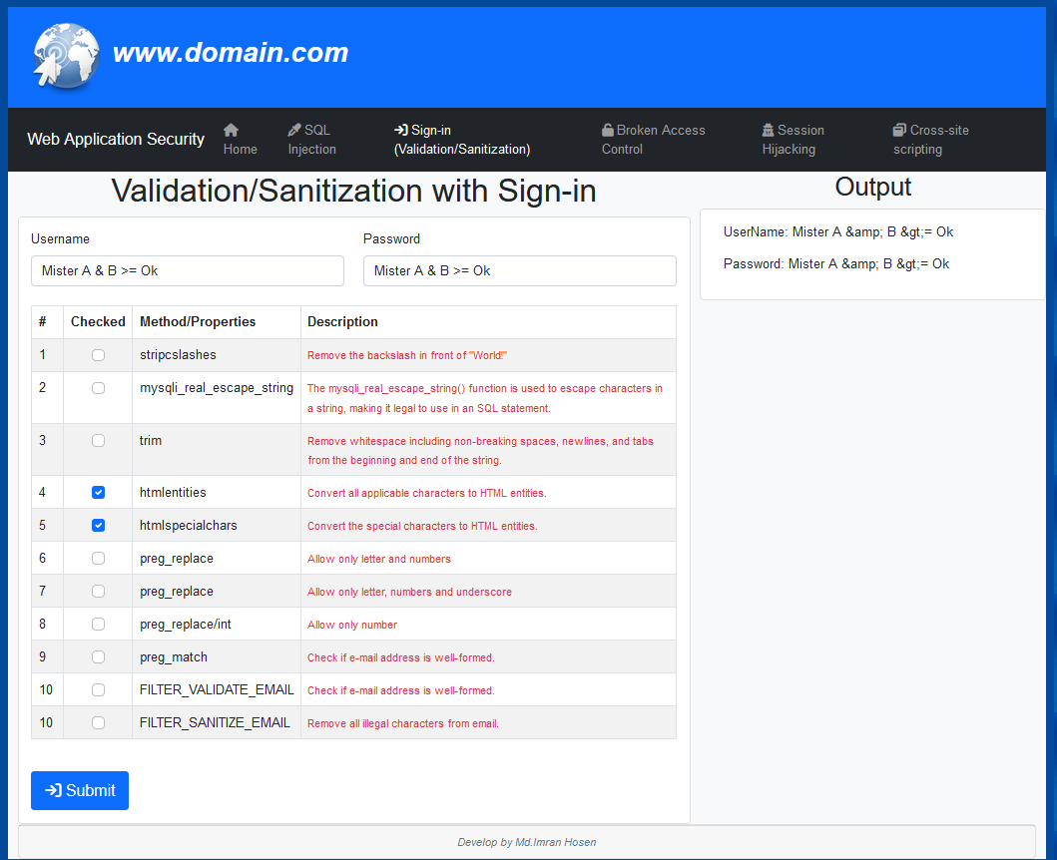

Figure : htmlentities() and htmlspecialchars() convert all applicable characters and special characters to HTML entities.

11.4 preg_replace() in PHP

preg_replace() in PHP – this function is used to perform a pattern match on a string and then replace the match with the specified text.

**Example:**

**<?php**

$username = “user@nameisone&two”

$username = preg_replace('/[^-a-zA-Z0-9]/','', $username); // Allow only letter and numbers

echo $username;

?>

**Output is: usernameisonetwo**

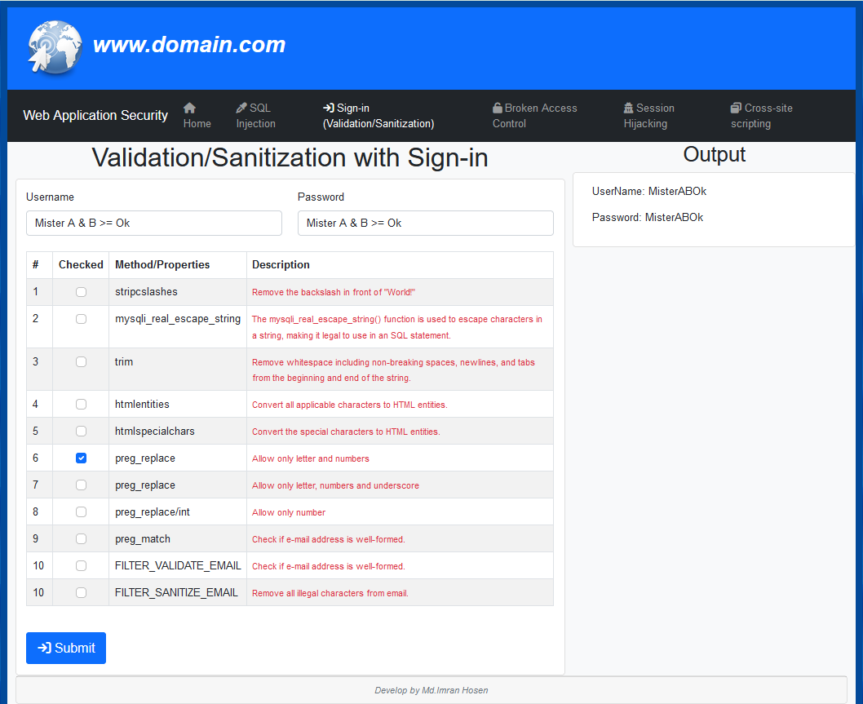

Figure : preg_replace() – allow only numer and letters

11.5 preg_match in PHP

preg_match() in PHP – this function is used to perform pattern matching in PHP on a string. It returns true if a match is found and false if a match is not found.

**Example:**

<?php

$var_preg_m = “imran@gmail.com”;

if (!preg_match("/^[a-zA-Z0-9._-]+@[a-zA-Z0-9-]+\.[a-zA-Z.]{2,5}$/", $var_preg_m)) {

$output = $var_preg_m." Invalid email format ";

}else{

$output = $var_preg_m." Valid email format ";

}

Echo $output;

**Output**: imran@gmail.com Valid email format

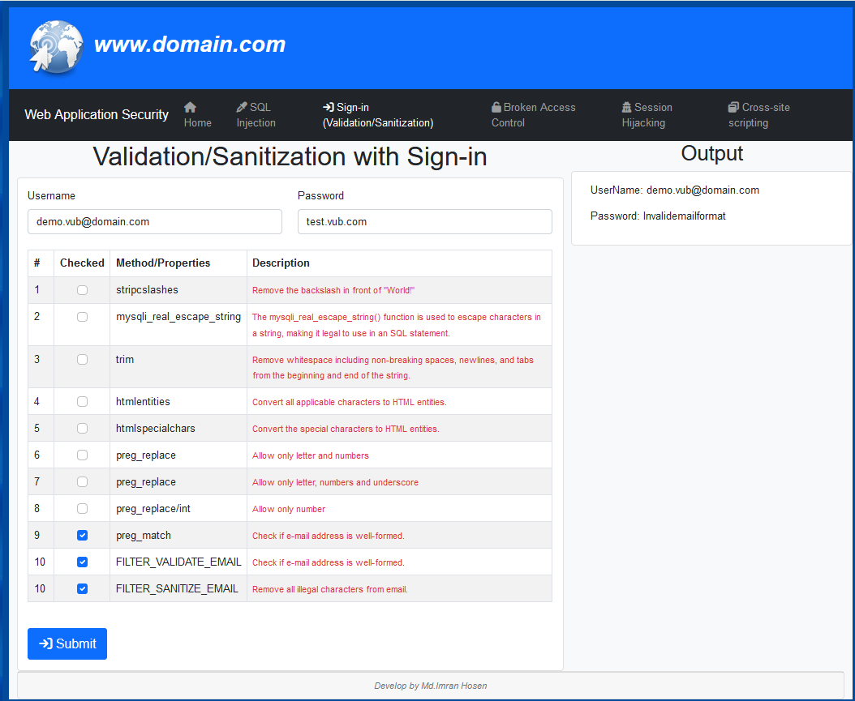

Figure : preg_match() – allow only valid email format

11.6 Sign-in with Validation

Database: du_vub

Table: users, posts, session_manage, access_token

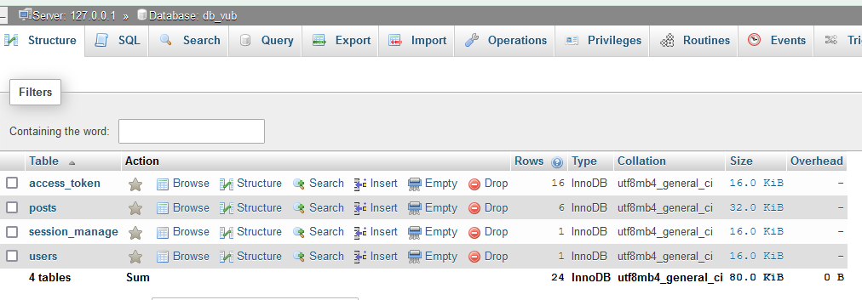

Figure : Database to all tables

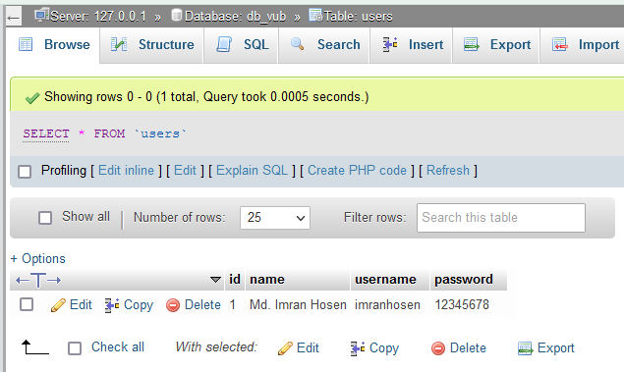

Figure : Database users table data

**Sig-in using username and password with input data Sanitization**

Username: imranhosen

Password: 12345678

Input correct username and password then click on submit button.

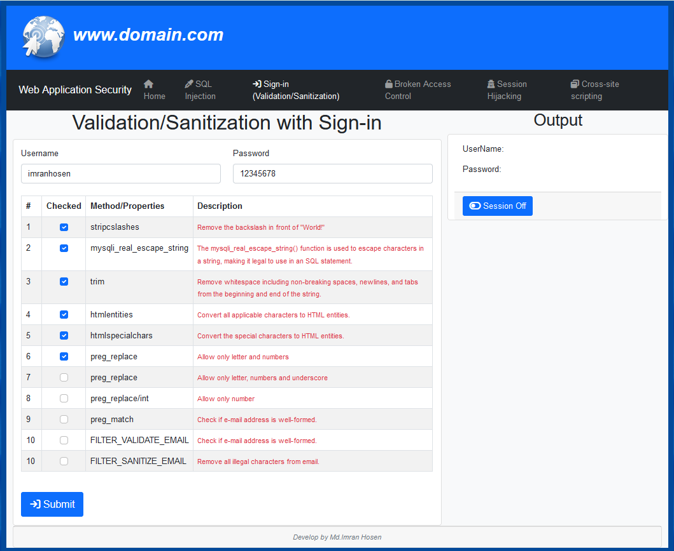

Figure : User login with Sanitization

Login to session save with browser and token key generate to save browser and database.

Redirect to post page. “www.domain.com/login.php to www.domain.com/index.php “

If you following below

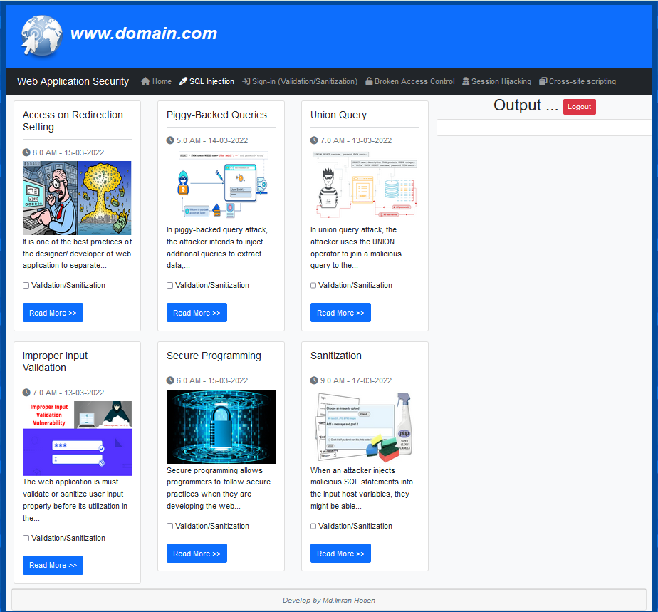

Figure : After Login

**Display Post Details without parameter validation**

http://localhost/vub/index.php?action=6&submit=Read+More+%3E%3E

If you following below

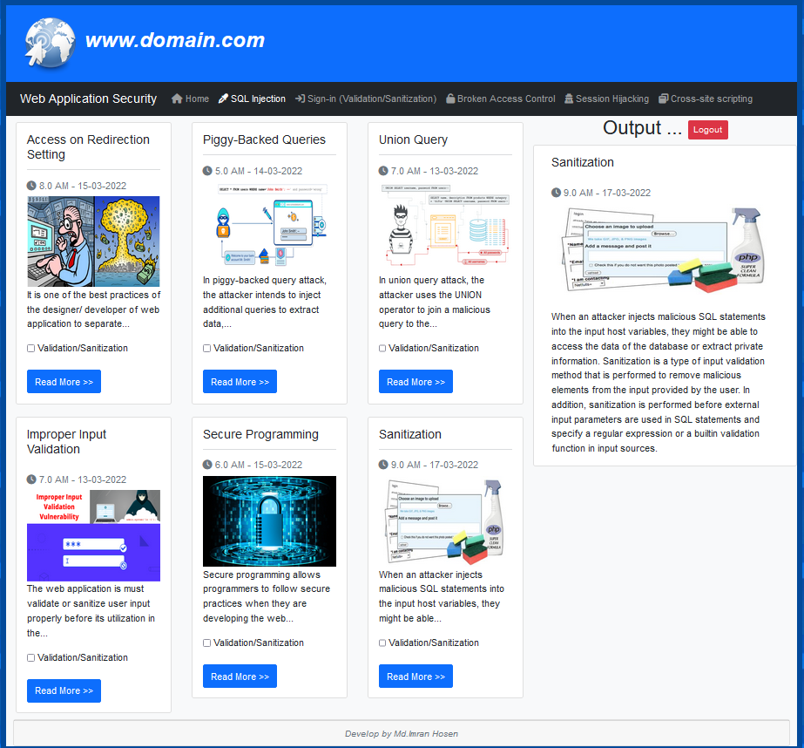

Figure : Post details without parameter validation

**Post details are not displayed.**

[http://localhost/vub/index.php?action=6**\**&submit=Read+More+%3E%3E](http://localhost/vub/index.php?action=6\&submit=Read+More+%3E%3E)

Because: ?action=6\

Invalid action value

If you following below

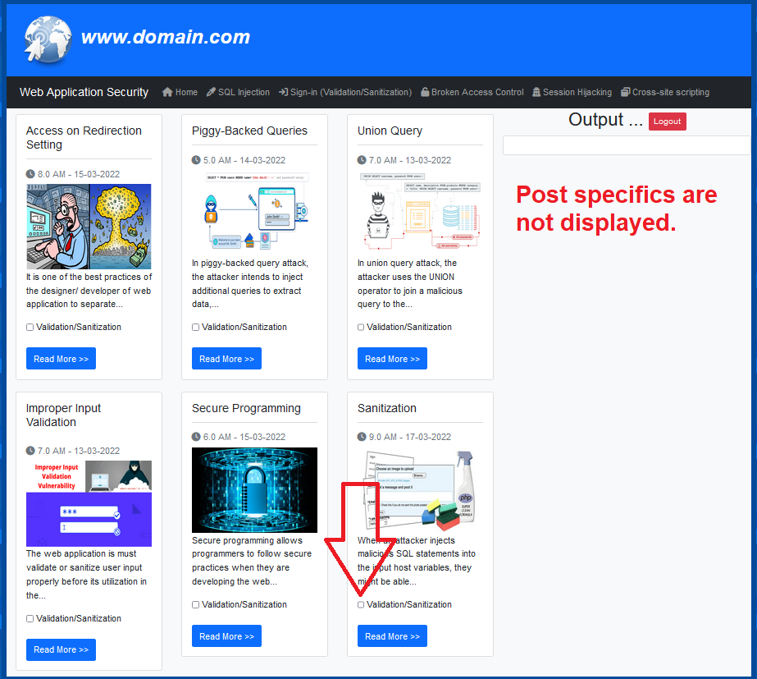

Figure : Post specifics are not displayed.

**Display Post Details without parameter validation**

<http://localhost/vub/index.php?action=6>’ UNION &submit=Read+More+%3E%3E

If you following below

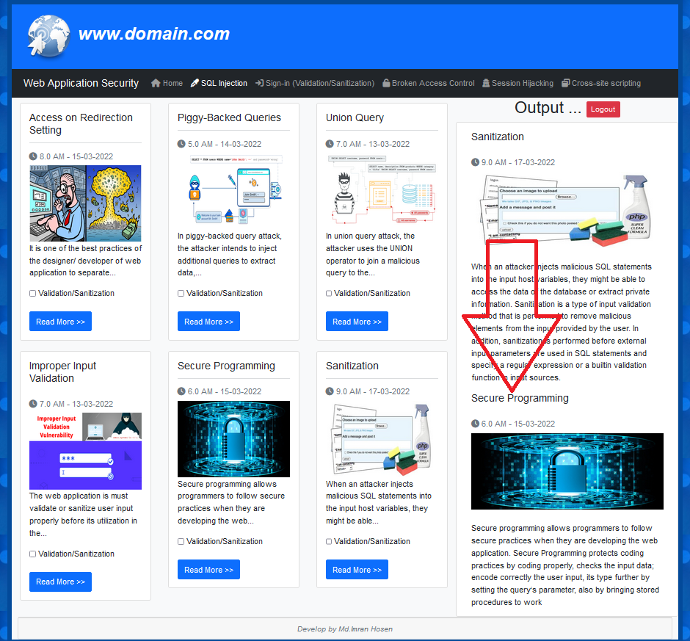

Figure : Post id with union query use

**Display Post Details with parameter validation**

http://localhost/vub/index.php?action=6\\\\&submit=Read+More+%3E%3E

If you following below

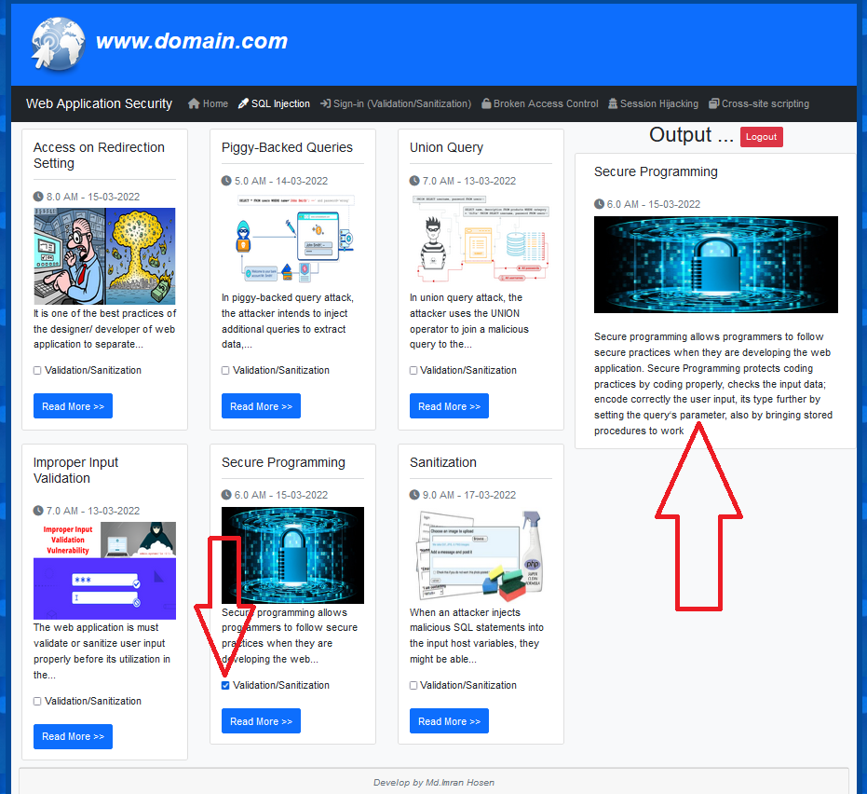

Figure : Post details is show with parameter validation

Chapter 12  
Conclusion and Future Works

12.1 Findings of the project

12.2 Limitations and Future works

References

|  |  |
| --- | --- |
| [1] | Cybercrime to Cost the World $10.5 Trillion Annually By 2025 Sausalito, Calif. – Nov. 13, 2020  https://cybersecurityventures.com/hackerpocalypse-cybercrime-report-2016/ |
| [2] | 300 Billion: That's How Many Passwords May Be In Use By 2020 https://www.inc.com/joseph-steinberg/300-billion-thats-how-many-passwords-may-be-in-use-by-2020.html |
| [3] | Microsoft Docs - SQL Injection  https://docs.microsoft.com/en-us/sql/relational-databases/security/sql-injection?view=sql-server-ver15 |
| [4] | 2021 Global Threat Intelligence Report released by NTT Corporation  https://services.global.ntt/en-us/insights/2021-global-threat-intelligence- report |
| [5] | A Survey on Detection and Prevention of Web Vulnerabilities https://pdfs.semanticscholar.org/2357/ac4b1fda3ac3206f5603712c842606e2fd5b.pdf |
| [6] | OWASP Top 10 Web Application Security Risks 2021  https://owasp.org/www-project-top-ten/ |
| [7] | Towards a Deep Learning Model for Vulnerability Detection on Web Application Variants “2020 IEEE International Conference on Software Testing, Verification and Validation Workshops “  DOI 10.1109/ICSTW50294.2020.00083 |
| [8] | Young-Su JANG “Detection of SQL Injection Vulnerability in Embedded SQL “  DOI: 10.1587/transinf.2019EDL8143 |
| [9] | Web Application Security, Testing & Scanning - PortSwigger  https://portswigger.net |
| [10] | Peng Tang, Weidong Qiu, Zheng Huang, Huijuan Lian, Guozhen Liu “Detection of SQL injection based on artificial neural network”, Knowledge-Based Systems, Volume 190, 2020, 105528, https://doi.org/10.1016/j.knosys.2020.105528. |
| [11] | W3af  Url: http://w3af.org/ |
| [12] | Rachid Ait daoud, Karim Abouelmehdi, Hayat Khaloufi, Abderrahim Beni-hssane – “Risk assessment of SQL injection: An experimental study”, 2021 7th International Conference on Optimization and Applications (ICOA)  https://doi.org/10.1109/ICOA51614.2021.9442630 |
| [13] | Aditya Rai, MD. Mazharul Islam Miraz, Deshbandhu Das, Harpreet Kaur, Swati – “SQL Injection: Classification and Prevention”  https://doi.org/10.1109/ICIEM51511.2021.9445347 |
| [14] | Ines Jemal , Omar Cheikhrouhou, Habib Hamam and Adel Mahfoudhi – “SQL Injection Attack Detection and Prevention Techniques Using Machine Learning”  https://www.ripublication.com/ijaer20/ijaerv15n6_06.pdf |
| [15] | Iberia Medeiros, Nuno Neves – “Effect of Coding Styles in Detection of Web Application Vulnerabilities”, 2020 16th European Dependable Computing Conference (EDCC)  DOI 10.1109/EDCC51268.2020.00027 |
| [16] | DarkReading, “Sql injection attacks represent two-third of all web app attacks,” 2019,  https://www.darkreading.com/attacks-breaches/sqlinjection-attacks-represent-two-third-of-all-web-app-attacks/d/did/1334960. |

[17] Halfond, William & Viegas, Jeremy & Orso, Alessandro. (2006).

A Classification of SQL Injection Attacks and Countermeasures.

[18] Hacking Articles – Commix

https://www.hackingarticles.in/commix-command-injection-exploiter-beginners-guide/

[19] Commix - Automated All-in-One OS Command Injection Exploitation Tool

https://commixproject.com/

[20] Limei Ma, Yijun Gao, Dongmei Zhao, Chen Zhao

Research on SQL Injection Attack and Prevention Technology Based on Web

2019 International Conference on Computer Network, Electronic and Automation (ICCNEA)

DOI 10.1109/ICCNEA.2019.00042

[21] Stackoverflow - mysqli_real_escape_string - example for 100% safety

https://stackoverflow.com/questions/34052328/mysqli-real-escape-string-example-for-100-safety

Appendix A.

**# header.php //vub/inc/header.php**

<?php

//error reporting on with 100

error_reporting(100);

// Database Connection

$mysqli = new mysqli("localhost","root","","db_vub");

// Check connection

if ($mysqli -> connect_errno) {

echo "Failed to connect to MySQL: " . $mysqli -> connect_error;

exit();

}

//Session start check and start

if (session_status() === PHP_SESSION_NONE) {

session_start();

}

// get session flag variable

$login_key_ = '';

$login_id_ = '';

$login_name_ = '';

$login_username_ = '';

$token_id_ = '';

// if session will create to store variable

if (isset($_SESSION["login_key"])) {

$login_key_ = $_SESSION["login_key"];

$login_id_ = $_SESSION["login_id"];

$login_name_ = $_SESSION["login_name"];

$login_username_ = $_SESSION["login_username"];

$token_id_ = $_SESSION["token_id"];

}

// logout session destroy and unset

if (isset($_GET['logout'])) {

session_destroy();

session_unset();

header("Location:login.php");

}

// String limited for display function create

function textShorten($text, $limit = 60) {

$text = strip_tags($text);

$text = $text. " ";

$text = substr($text, 0, $limit);

$text = substr($text, 0, strrpos($text, ' '));

$text = $text."...";

return $text;

}

// Integer parameter validation

function validInt($data) {

$data = preg_replace('/[^0-9]/', '', $data); // Allow only number

$data = preg_replace('/\D/', '', $data); // Allow only number

$data = (int)$data; // Convert number

return $data;

}

// Extracting page names from website URLs Like login.php

$page_name = basename($_SERVER['REQUEST_URI'], '?' . $_SERVER['QUERY_STRING']);

?>

<!doctype html>

<html lang="en">

<head>

<meta charset="utf-8">

<meta name="viewport" content="width=device-width, initial-scale=1">

<!-- Bootstrap CSS -->

<link href="https://cdn.jsdelivr.net/npm/bootstrap@5.1.3/dist/css/bootstrap.min.css" rel="stylesheet" integrity="sha384-1BmE4kWBq78iYhFldvKuhfTAU6auU8tT94WrHftjDbrCEXSU1oBoqyl2QvZ6jIW3" crossorigin="anonymous">

<link rel="stylesheet" type="text/css" href="https://cdnjs.cloudflare.com/ajax/libs/font-awesome/6.0.0/css/all.min.css">

<style type="text/css">

body{

font-family: Helvetica, sans-serif;

}

.mdimranhosen_s1 {margin:10px 5px;}

.form-check .form-check-input{margin-left: -0.5em;}

</style>

<title>Web Application Security</title>

</head>

<body style="background-image: url('img/bg.png');">

**#manu.php //vub/inc/manu.php**

<div class="col-lg-12" style="padding-left: 0px;padding-right: 0px;">

<nav class="navbar navbar-dark bg-primary">

<div class="container-fluid">

<a class="navbar-brand" href="#">

<img src="img/web_logo.png" alt="" width="100" height="100" class="d-inline-block">

<span style="font-size: 35px;font-weight: bold;font-style: italic;"> www.domain.com </span>

</a>

</div>

</nav>

<nav class="navbar navbar-expand-lg navbar-dark bg-dark">

<div class="container-fluid">

<a class="navbar-brand">Web Application Security</a>

<button class="navbar-toggler" type="button" data-bs-toggle="collapse" data-bs-target="#navbarNav" aria-controls="navbarNav" aria-expanded="false" aria-label="Toggle navigation">

<span class="navbar-toggler-icon"></span>

</button>

<div class="collapse navbar-collapse" id="navbarNav">

<ul class="navbar-nav">

<li class="nav-item">

<a class="nav-link" aria-current="page" href="index.php"><i class="fa fa-home"></i> Home </a>

</li>

<li class="nav-item">

<a class="nav-link <?php if($page_name == 'index.php'){ echo 'active'; } ?>" href="index.php"> <i class="fa fa-eyedropper"></i> SQL Injection</a>

</li>

<li class="nav-item">

<a class="nav-link <?php if($page_name == 'login.php') { echo 'active'; } ?>" href="login.php"> <i class="fa fa-sign-in"></i> Sign-in (Validation/Sanitization) </a>

</li>

<li class="nav-item">

<a class="nav-link" href="#"> <i class="fa fa-unlock"></i> Broken Access Control</a>

</li>

<li class="nav-item">

<a class="nav-link" href="#"><i class="fa fa-user-secret"></i> Session Hijacking</a>

</li><li class="nav-item">

<a class="nav-link" href="#"> <i class="fa fa-window-restore"></i> Cross-site scripting</a>

</li>

</ul>

</div>

</div>

</nav>

</div>

**#footer.php //vub/inc/footer.php**

<script src="https://cdnjs.cloudflare.com/ajax/libs/jquery/3.6.0/jquery.min.js" integrity="sha512-894YE6QWD5I59HgZOGReFYm4dnWc1Qt5NtvYSaNcOP+u1T9qYdvdihz0PPSiiqn/+/3e7Jo4EaG7TubfWGUrMQ==" crossorigin="anonymous" referrerpolicy="no-referrer"></script>

<script src="https://cdn.jsdelivr.net/npm/bootstrap@5.1.3/dist/js/bootstrap.bundle.min.js" integrity="sha384-ka7Sk0Gln4gmtz2MlQnikT1wXgYsOg+OMhuP+IlRH9sENBO0LRn5q+8nbTov4+1p" crossorigin="anonymous"></script>

</body>

</html>

**# session_off_on.php //vub/inc/session_off_on.php**

<?php include "header.php"; ?>

<?php

if (!empty($login_key_)) {

echo '<script>window.location.href="../index.php";</script>';

}

if($_SERVER['REQUEST_METHOD'] == 'GET' && $_GET['verdata'] == 98) {

$status = $_GET["ver_on_off"];

$verdata = $_GET["verdata"];

if(!empty($verdata) && (($status == 0) || ($status == 1))) {

try {

$status = validInt($status);

$status = mysqli_real_escape_string($mysqli, $status);

$query = "UPDATE `session_manage` SET session_on_off = '$status' WHERE `id` = 1";

$resd = mysqli_query($mysqli, $query);

} catch (Exception $e) {

}

}

}

?>

<?php include "footer.php"; ?>

**#login.php // vub/login.php**

<?php include "inc/header.php"; ?>

<?php

if (!empty($login_key_)) {

echo '<script>window.location.href="index.php";</script>';

}

//flag variable for error handling

$username = '';

$password = '';

$stripcslashes = '';

$sqlreales = '';

$trim_ = '';

$htmlspecialchars_ = '';

$htmlentities_ = '';

$preg_replace_1 = '';

$preg_replace_2 = '';

$preg_replace_3 = '';

$preg_match_ = '';

$filter_v_email_ = '';

// Get request data

if (isset($_POST['submit'])) {

$username = $_POST['username'];

$password = $_POST['password'];

$stripcslashes = $_POST['stripcslashes'];

$sqlreales = $_POST['sqlreales'];

$trim_ = $_POST['trim_'];

$htmlspecialchars_ = $_POST['htmlspecialchars_'];

$htmlentities_ = $_POST['htmlentities_'];

$preg_replace_1 = $_POST['preg_replace_1'];

$preg_replace_2 = $_POST['preg_replace_2'];

$preg_replace_3 = $_POST['preg_replace_3'];

$preg_match_ = $_POST['preg_match_'];

$filter_v_email_ = $_POST['filter_v_email_'];

$sanitize_email_ = $_POST['sanitize_email_'];

// stripcslashes

if (!empty($stripcslashes)) {

$username = stripcslashes($username); //Remove the backslas

$password = stripcslashes($password); //Remove the backslas

}

// mysqli_real_escape_string - Remove the special characters from the

if (!empty($sqlreales)) {

$username = mysqli_real_escape_string($mysqli, $username);

$password = mysqli_real_escape_string($mysqli, $password);

}

// trim - Remove characters from both sides of a string.

if (!empty($trim_)) {

$username = trim($username);

$password = trim($password);

}

// htmlentities() - function convert all applicable characters to HTML entities

if (!empty($htmlentities_)) {

$username = htmlentities($username); //Convert all applicable characters to HTML entities

$password = htmlentities($password); //Convert all applicable characters to HTML entities

}

// htmlspecialchars() - function covnerts special characters into HTML entities

if (!empty($htmlspecialchars_)) {

$username = htmlspecialchars($username); //Covnerts special characters into HTML entities

$password = htmlspecialchars($password); //Covnerts special characters into HTML entities

}

// preg_replace - Allow only letter and numbers

if (!empty($preg_replace_1)) {

$username = preg_replace('/[^-a-zA-Z0-9]/','', $username); // Allow only letter and numbers

$password = preg_replace('/[^-a-zA-Z0-9]/','', $password); // Allow only letter and numbers

}

// preg_replace - Allow only letter, numbers and underscore '_'

if (!empty($preg_replace_2)) {

$username = preg_replace('/[^-a-zA-Z0-9_]/','', $username); // Allow only letter, numbers and underscore '_'

$password = preg_replace('/[^-a-zA-Z0-9_]/','', $password); // Allow only letter, numbers and underscore '_'

}

// preg_replace - Allow only number

if (!empty($preg_replace_3)) {

$username = preg_replace('/[^0-9]/', '', $username); // Allow only number

$password = preg_replace('/[^0-9]/', '', $password); // Allow only number

// OR

$username = preg_replace('/\D/', '', $username); // Allow only number

$password = preg_replace('/\D/', '', $password); // Allow only number

// OR

$username = (int)$username; // Convert number

$password = (int)$password; // Convert number

}

// preg_match - Check if e-mail address is well-formed.

if (!empty($preg_match_)) {

if (!preg_match("/^[a-zA-Z0-9._-]+@[a-zA-Z0-9-]+\.[a-zA-Z.]{2,5}$/", $username)) {

$username = "Invalid email format";

}

if (!preg_match("/^[a-zA-Z0-9._-]+@[a-zA-Z0-9-]+\.[a-zA-Z.]{2,5}$/", $password)) {

$password = "Invalid email format";

}

}

// FILTER_VALIDATE_EMAIL

if (!empty($filter_v_email_)) {

if (!filter_var($username, FILTER_VALIDATE_EMAIL)) {

$username = "Invalid email format";

}

if (!filter_var($password, FILTER_VALIDATE_EMAIL)) {

$password = "Invalid email format";

}

}

// FILTER_SANITIZE_EMAIL() - Remove all illegal characters from email

if (!empty($sanitize_email_)) {

$username = filter_var($username, FILTER_SANITIZE_EMAIL); //Remove all illegal characters from email

$password = filter_var($password, FILTER_SANITIZE_EMAIL); //Remove all illegal characters from email

}

// SQL query for login 1' OR '1 = 1

$sql = "SELECT * FROM users WHERE username = '$username' AND password = '$password'";

$res = mysqli_query($mysqli, $sql);

$numrows = mysqli_num_rows($res);

if ($numrows == 1) {

while($rowss = $res->fetch_assoc()){

$id = $rowss['id'];

$name = $rowss['name'];

$username = $rowss['username'];

$password = $rowss['password'];

//data store to session

$_SESSION["login_id"] = $id;

$_SESSION["login_name"] = $name;

$_SESSION["login_username"] = $username;

$dt = date("d-m-Y-h:i:sa");

$access_token_insert = md5($id.$dt); //create token with md5 and date method useing

$_SESSION["login_key"] = $access_token_insert;

$sqlat = "INSERT INTO access_token (user_id,TOKEN) VALUES('$id','$access_token_insert')";

$sqlAccessToken = mysqli_query($mysqli, $sqlat);

$accetid = $mysqli->insert_id; // Get last insert id

$_SESSION["token_id"] = $accetid;

#header("Location:index.php");

echo "<script>window.location.href='index.php';</script>";

}

}

}

?>

<div class="container bg-light" style="border: 10px solid #034A9A;">

<div class="row justify-content-center">

<?php include "inc/manu.php"; ?>

<div class="col-lg-12">

<div class="row"><div class="col-lg-8">

<div class="row"><div class="col-lg-12">

<center><h1> Validation/Sanitization with Sign-in </h1></center>

</div><div class="col-lg-12">

<div class="card"> <div class="card-body">

<!-- Form Start -->

<form action="" method="post">

<div class="row"><div class="col-lg-6">

<label for="username" class="form-label">Username</label>

<input type="text" class="form-control" id="username" name="username" <?php if (!empty($username)) { echo "value='".$username."'"; } else{ echo 'placeholder="Enter your Username"'; } ?>>

</div><div class="col-lg-6">

<label for="password" class="form-label">Password</label>

<input type="text" class="form-control" id="password" name="password" <?php if (!empty($password)) { echo "value='".$password."'"; } else{ echo 'placeholder="Enter your Password"'; } ?>>

</div></div>

<div class="row"><div class="col-lg-12">

<br>

<div class="table-responsive">

<table class="table table-bordered table-striped">

<thead><tr>

<th width="5%">#</th>

<th width="5%">Checked</th>

<th width="20%">Method/Properties</th>

<th width="60%">Description</th>

</tr></thead>

<tbody><tr>

<td>1</td>

<td align="center"><input type="checkbox" <?php if (!empty($stripcslashes)) { ?> checked <?php } ?> class="form-check-input" id="stripcslashes" name="stripcslashes"></td>

<td>stripcslashes</td>

<td><small class="text-danger">Remove the backslash in front of "World!"</small></td>

</tr><tr><td>2</td>

<td align="center"><input type="checkbox" <?php if (!empty($sqlreales)) { ?> checked <?php } ?> class="form-check-input" id="sqlreales" name="sqlreales"></td>

<td>mysqli_real_escape_string</td>

<td><small class="text-danger">The mysqli_real_escape_string() function is used to escape characters in a string, making it legal to use in an SQL statement.</small></td>

</tr> <tr> <td>3</td>

<td align="center"><input type="checkbox" <?php if (!empty($trim_)) { ?> checked <?php } ?> class="form-check-input" id="trim_" name="trim_"></td>

<td>trim</td>

<td><small class="text-danger"> Remove whitespace including non-breaking spaces, newlines, and tabs from the beginning and end of the string. </small></td>

</tr><tr> <td>4</td>

<td align="center"><input type="checkbox" <?php if (!empty($htmlentities_)) { ?> checked <?php } ?> class="form-check-input" id="htmlentities_" name="htmlentities_"></td>

<td>htmlentities</td>

<td><small class="text-danger"> Convert all applicable characters to HTML entities.</small></td>

</tr><tr><td>5</td>

<td align="center"><input type="checkbox" <?php if (!empty($htmlspecialchars_)) { ?> checked <?php } ?> class="form-check-input" id="htmlspecialchars_" name="htmlspecialchars_"></td>

<td>htmlspecialchars</td>

<td><small class="text-danger"> Convert the special characters to HTML entities. </small></td>

</tr><tr><td>6</td>

<td align="center"><input type="checkbox" <?php if (!empty($preg_replace_1)) { ?> checked <?php } ?> class="form-check-input" id="preg_replace_1" name="preg_replace_1"></td>

<td>preg_replace</td>

<td><small class="text-danger">Allow only letter and numbers </small></td>

</tr><tr><td>7</td>

<td align="center"><input type="checkbox" <?php if (!empty($preg_replace_2)) { ?> checked <?php } ?> class="form-check-input" id="preg_replace_2" name="preg_replace_2"></td>

<td>preg_replace</td>

<td><small class="text-danger"> Allow only letter, numbers and underscore </small></td>

</tr><tr><td>8</td>

<td align="center"><input type="checkbox" <?php if (!empty($preg_replace_3)) { ?> checked <?php } ?> class="form-check-input" id="preg_replace_3" name="preg_replace_3"></td>

<td>preg_replace/int</td>

<td><small class="text-danger">Allow only number </small></td>

</tr><tr> <td>9</td>

<td align="center"><input type="checkbox" <?php if (!empty($preg_match_)) { ?> checked <?php } ?> class="form-check-input" id="preg_match_" name="preg_match_"></td>

<td>preg_match</td>

<td><small class="text-danger"> Check if e-mail address is well-formed. </small></td>

</tr><tr><td>10</td>

<td align="center"><input type="checkbox" <?php if (!empty($filter_v_email_)) { ?> checked <?php } ?> class="form-check-input" id="filter_v_email_" name="filter_v_email_"></td>

<td>FILTER_VALIDATE_EMAIL</td>

<td><small class="text-danger"> Check if e-mail address is well-formed. </small></td>

</tr> <tr><td>10</td>

<td align="center"><input type="checkbox" <?php if (!empty($sanitize_email_)) { ?> checked <?php } ?> class="form-check-input" id="sanitize_email_" name="sanitize_email_"></td>

<td>FILTER_SANITIZE_EMAIL</td>

<td><small class="text-danger"> Remove all illegal characters from email. </small></td>

</tr></tbody>

</table>

</div></div></div>

<div class="row"><div class="col-lg-12">

<br>

<button type="submit" name="submit" class="btn btn-primary btn-lg"><i class="fa fa-sign-in"></i> Submit </button>

</div></div> </form>

<!-- Form End -->

</div></div></div></div></div>

<div class="col-lg-4">

<div class="row"><div class="col-lg-12">

<center><h2>Output</h2></center>

</div>

<div class="card">

<div class="card-body">

<div class="col-lg-12">

<p>UserName: <?php echo $username; ?></p>

<p>Password: <?php echo $password; ?></p>

</div></div>

<div class="card-footer">

<div class="col-lg-12">

<?php

$session_on_off = 0;

$sqls_session = "SELECT * FROM session_manage WHERE id = 1";

$ress_session = mysqli_query($mysqli, $sqls_session);

$numrowss_session = mysqli_num_rows($ress_session);

if ($numrowss_session >= 1) {

while($row_sess = $ress_session->fetch_assoc()) {

$session_on_off = $row_sess['session_on_off'];

}

}

if ($session_on_off == 0) {

?>

<a href="javascript:void(0)" class="btn btn-primary session_off_on" data-ver_on_off="1"><i class="fa fa-toggle-off fa-lg"></i> Session Off </a>

<?php } else{ ?>

<a href="javascript:void(0)" class="btn btn-danger session_off_on" data-ver_on_off="0"><i class="fa fa-toggle-on fa-lg"> </i> Session On </a>

<?php } ?>

</div></div></div></div></div></div>

<div class="col-lg-12">

<div class="card text-center">

<div class="card-footer text-muted">

<small style="font-style: italic;">Develop by Md.Imran Hosen</small>

</div></div></div></div></div>

<?php include "inc/footer.php"; ?>

<script type="text/javascript">

$(document).ready(function(){

// Session off on with jQuery and Ajax

$('.session_off_on').on('click', function() {

var ver_on_off = $(this).data('ver_on_off');

if(confirm('Do you really want to Change Session Status ? ')) {

$.ajax({url:"inc/session_off_on.php?ver_on_off="+ver_on_off+"&verdata=98", success:function(session_data) {

window.location.href="";

}

});

}

});

});

</script>

**#index.php //vub/index.php**

<?php include "inc/header.php"; ?>

<?php

// if Session Status On Start

$session_on_off = 0;

$sqls_session = "SELECT * FROM session_manage WHERE id = 1";

$ress_session = mysqli_query($mysqli, $sqls_session);

$numrowss_session = mysqli_num_rows($ress_session);

if ($numrowss_session >= 1) {

while($row_sess = $ress_session->fetch_assoc()) {

$session_on_off = $row_sess['session_on_off'];

}

}

if ($session_on_off == 0) {

// if Session Status On working

if (empty($login_key_) || empty($token_id_) || empty($login_id_) || empty($login_name_) || empty($login_username_)) {

echo '<script>window.location.href="login.php";</script>';

} else{

$login_id_ = validInt($login_id_);

$token_id_ = validInt($token_id_);

$token_id_ = mysqli_real_escape_string($mysqli, $token_id_);

$login_id_ = mysqli_real_escape_string($mysqli, $login_id_);

$login_key_ = mysqli_real_escape_string($mysqli, $login_key_);

$cksql = "SELECT * FROM access_token WHERE id = '$token_id_' AND user_id = '$login_id_' AND TOKEN = '$login_key_'";

$resck = mysqli_query($mysqli, $cksql);

$numrowsck = mysqli_num_rows($resck);

if ($numrowsck >= 1) {

} else{

echo '<script>window.location.href="index.php?logout";</script>';

}

}

}

// if Session Status On End

$post_id = '';

$validcheck = '';

if (isset($_GET['submit'])) {

$post_id = $_GET['action'];

$validcheck = $_GET['validcheck'];

}

?>

<div class="container bg-light" style="border: 10px solid #034A9A;">

<div class="row justify-content-center">

<?php include "inc/manu.php"; ?>

<div class="col-lg-12">

<div class="row">

<div class="col-lg-8">

<div class="row">

<!-- Post Start -->

<?php

$sql = "SELECT * FROM posts ORDER BY id ASC";

$res = mysqli_query($mysqli, $sql);

$numrows = mysqli_num_rows($res);

if ($numrows >= 1) {

while($rows = $res->fetch_assoc()){

$id = $rows['id'];

$title = $rows['title'];

$description = $rows['description'];

$create_date = $rows['create_date'];

$img = $rows['img'];

?>

<div class="col-lg-4 col-sm-6">

<div class="card mdimranhosen_s1">

<div class="card-body">

<h5 class="card-title"><?php echo $title; ?></h5>

<h6 class="card-subtitle mb-2 text-muted"><hr><i class="fa fa-clock"></i> <?php echo $create_date; ?></h6>

<img src="img/post/<?php echo $img; ?>" width="100%" height="150px;">

<p class="card-text"><?php echo textShorten($description, 100); ?></p>

<form action="" method="get" id="form-id">

<input type="hidden" name="action" value="<?php echo $id; ?>">

<input type="checkbox" name="validcheck"

<?php

// Checkbox checked or not

if (!empty($post_id)) {

$post_id_n = preg_replace('/\D/', '', $post_id);

if (($post_id_n == $id) && !empty($validcheck)) {

echo ' checked ';

}

}

?>

> Vlidation/Sanitization

<br><br>

<input type="submit" class="btn btn-primary" name="submit" value="Read More >>">

</form>

</div></div></div>

<?php } } ?>

<!-- Post End -->

</div></div>

<!-- Output Data Start -->

<div class="col-lg-4">

<div class="row ">

<div class="col-lg-12">

<center><h2>Output ... <small class="pull-right"><a class="btn btn-danger btn-sm" href="?logout">Logout</a></small></h2> </center>

</div>

<div class="card">

<div class="card-body">

<div class="col-lg-12">

<?php

if (!empty($post_id)) {

if (!empty($validcheck)) {

$post_id = validInt($post_id);

$post_id = mysqli_real_escape_string($mysqli, $post_id);

}

$sqld = "SELECT * FROM posts WHERE id = '$post_id'";

$resd = mysqli_query($mysqli, $sqld);

$numrowsd = mysqli_num_rows($resd);

if ($numrowsd >= 1) {

while($rowsd = $resd->fetch_assoc()) {

$titled = $rowsd['title'];

$descriptiond = $rowsd['description'];

$create_dated = $rowsd['create_date'];

$imgd = $rowsd['img'];

?>

<h5 class="card-title"><?php echo $titled; ?></h5>

<h6 class="card-subtitle mb-2 text-muted"><hr><i class="fa fa-clock"></i> <?php echo $create_dated; ?></h6>

<img src="img/post/<?php echo $imgd; ?>" width="100%" height="150px;">

<p class="card-text"><br><?php echo $descriptiond; ?></p>

<?php } } } ?>

</div></div></div></div></div>

<!-- Output Data End -->

</div>

<!-- Footer Start -->

<div class="col-lg-12">

<div class="card text-center">

<div class="card-footer text-muted">

<small style="font-style: italic;">Develop by Md.Imran Hosen</small>

</div></div></div>

<!-- Footer End -->

</div></div>

<?php include "inc/footer.php"; ?>

**SQL Database:**

* All Table’s



* Users Table Data



* Posts Table all data

